My Focus

Task Management User Manual

Prepared by: | HR Focus
Date: | 20 October 2026
Version: | 2026.10.1.0

Table of Contents
1. Start with your assigned work 1
2. Find work and choose a view 2
3. Maintain task and project context 3
4. Documents reporting and common problems 4

Start with your assigned work
Task Management connects personal tasks with manager and HR planning. Start in your permitted workspace, identify the next action and open the native record. This Coming Soon guide explains refreshed views. Actions depend on project membership, employee scope, settings and task rights.
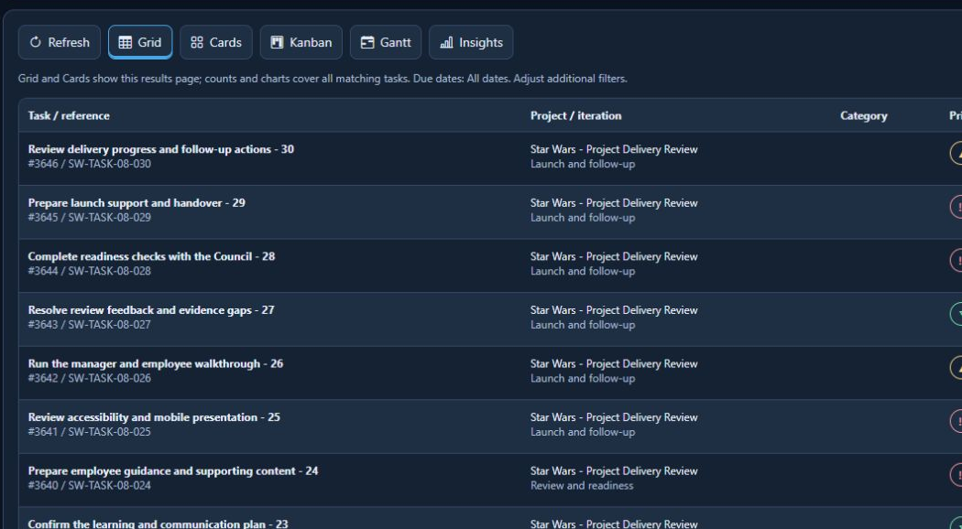
Task and project excerpt with fictional Star Wars work.
Read due-date scope and filter summary. Grid and Cards show the current results page; counts and charts can cover all matching tasks. A chart total need not equal the rows on one page.
- Find work and choose a view
1. Review task measures and choose the question, such as overdue or active work. Check date scope.
2. Use search and offered planning filters to choose project, phase, status, priority, person or period.
3. Use Grid for detail, Cards for quick review, Kanban for status and Gantt for dates/dependencies.
4. Use Insights to inspect matching work, then open a supporting task.
5. Open the native task and check title, reference, project/phase and people.
6. After an authorised update, refresh and confirm persisted state.
A board or timeline is a reading view until a permitted update is saved. Overdue, blocked and undated work need different follow-up. A capacity signal is not a certified staffing commitment.
- Maintain task and project context
Control or prerequisite | Use and boundary
Task record | Review description, acceptance criteria, priority, status, dates, progress, assignees, comments and documents in the native editor.
Planning | Manager and HR scope remains authorised. Project/phase actions depend on rights.
Dependencies and recurrence | Review configuration before changes. A recurring definition is not proof of executed recurrence.
Projects and delivery | Use permitted project routes. Financial/time actions have separate rights and validation.
Completion and rating | Follow configured resolve, close and rating rules. A progress value of 100 does not prove closure.
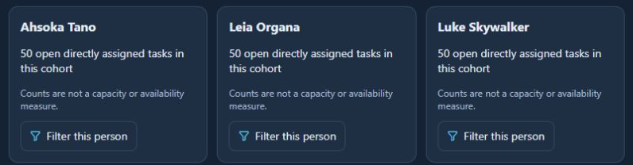
Fictional team planning counts and person filters; counts are not capacity measures.
Save deliberately and review the result. Cancelling or navigating away is not saving. Do not create notifications, time, claims, approvals or invoices in a demonstration without separate authorisation.
- Documents reporting and common problems
Open documents from the authorised task context. Do not copy or alter URLs to bypass restrictions. Report the task reference and symptom without private document contents. For export, inspect the actual file and its filtered scope.
- Missing task: check filters, dates, membership and employee/manager scope.
- Disabled action: check task state, project rights and feature setting.
- Stale view: refresh and reopen. Do not repeat a save with an uncertain outcome.
- Unexpected count: compare all matching tasks with the visible page and filters.
- Document error: confirm task context and ask support to check native list/viewer.
The historical Task 52 document-list deadlock has newer local read verification: repeated reads, native PDF viewing and cross-task denial passed on 20 October. This does not accept business writes or target concurrency. Appearance captures did not accept task saves, recurrence, workflow or export.

