My Focus

Chatbot 2.0 Configuration and Settings Guide

Prepared by: | HR Focus
Date: | 20 October 2026
Version: | 2026.10.1.0

Table of Contents
1. Configuration map and release scope 1
2. Settings and controlled rollout 2
3. Knowledge and fallback boundaries 3
4. Dashboard eligibility and card filters 4
5. Personal tools, team scope and documents 6
6. Reports, builder drafts and leave handoff 7
7. Support, attachments and recorded evidence 8
8. Analytics and human-reviewed publishing 9
9. Deployment and targeted verification 11
10. Troubleshooting and maintenance 12

Configuration map and release scope
This guide traces release 2026.10.1.0 to the current Web Forms frontend, API controllers and explicit tool services. It describes configuration and validation; it does not enable features, change permissions or execute deployment. Installed clients can have different setting values and business sources.
Configuration area | Behavior and requirements
ChatBot.aspx and Scripts/ChatBot.js | Main conversation, supported cards, history and source handoffs. The page checks the signed-in session.
Controllers/ChatbotController.vb | Bootstrap, grounded context, optional fallback, feedback, reports and Support actions.
Controllers/ChatbotPortalController.vb and ChatbotPortalWidget.aspx | Dashboard discovery, card filter preparation and eligible native-widget rendering.
HRFChatbotAnalytics.aspx | Authorised analytics and human-reviewed FAQ/Knowledge editorial workflow.
Modules/Setups/HRF_MYFOCUS_SETTING.aspx | MyFocus Settings editor. Locate the exact module/category/name triplet; menu placement varies.
Use the settings register for exact keys, runtime fallback values, deployment initial/default values and inspected script references. A code fallback is not the installed value. Some seeds use an initial value of 1 while storing a default of 0. Do not infer rollout from a screenshot or the default column alone.
- Settings and controlled rollout
Most preferences use HRF_MYFOCUS_SETTING, module Assistant, category Chatbot2. External dependencies are explicitly identified. The MyFocus Settings page saves through the established handle and updates the in-process settings collection. A direct SQL change may require the application’s established refresh or recycle process before every worker sees it. Test a fresh assistant bootstrap after a permitted change.
Configuration area | Behavior and requirements
Foundation | ApplicationName, DisplayTimeZone, QuickActionsEnabled, ConversationHistoryEnabled, PersonalDashboardEnabled and SmartPersonalToolsEnabled.
Grounded guidance and feedback | SourcePreviewEnabled, CommonSolutionsEnabled, IntentScreeningEnabled, FeedbackEnabled and the rating/comment/logging switches and labels.
Optional external services | AskAIEnabled, AskAIAutomaticFallback, BotFrameworkFallbackEnabled and SuppressBotFrameworkGreeting; external System/WebApi/OpenAIEnabled and Assistant/General/ChatBotDirectLineKey.
Module extensions | ReportingEnabled, InlineChartsEnabled, ReportPreviewsEnabled, ConversationalReportBuilderEnabled, document flags, ServiceDeskHandoffEnabled and SupportAttachmentsEnabled.
Dashboard and editorial access | DashboardVisualsEnabled, DashboardVisualsAllowedElementGuids, Analytics access/authoring/draft switches.
1. Record current and default values and relevant permissions before changing settings.
2. Confirm approved deployment sequence and dependencies. Do not run a whole release folder merely to enable a switch.
3. Pilot reviewed sources and read-only tools with representative roles.
4. Enable external services only after credential, outbound-connectivity and organisational review. Keep the Direct Line key out of browser code, screenshots and public documentation.
5. Refresh configuration through the established process. Check a fresh bootstrap, a positive role and a negative role.
The Logon system-settings control stores Assistant/General/ChatBotDirectLineKey. Chatbot2 preferences are read by their exact triplets; use the generic MyFocus Settings editor unless the installed client provides a dedicated screen. Frontend visibility is not a substitute for server gates.
- Knowledge and fallback boundaries
Grounded lookup searches configured Knowledge, suggestions and common solutions. The controller returns at most five Knowledge results. Dynamic My Information execution is bounded to three matching items, eight rows and twelve columns, using signed-in employee/user context. KnowledgeScopePolicy checks supported area/type pairs and active item, area, type and category metadata.
Configuration area | Behavior and requirements
FAQ / FAQ | Static reviewed guidance can be listed; this is distinct from an employee-specific query.
Knowledge / KnowledgeArticle | Static article content and source handoffs. Assign a policy owner and review cadence.
MyData / MyDataQuery | Dynamic data requires employee context and this explicit pair. A dynamic statement in another area does not become executable.
MyData / FAQ | A static entry requires employee context and no dynamic statement.
Other combinations | Unsupported pairs are not automatically visible or executable.
HRFKnowledge.aspx is the normal Knowledge handoff. HRFAgents.aspx exposes the configured agent catalogue. Navigation suggestions derive from authorised menu routes; a returned title does not manufacture access.
Ask AI requires Assistant/Chatbot2/AskAIEnabled plus System/WebApi/OpenAIEnabled. Automatic AI fallback is a separate preference. Bot Framework fallback obtains a token on the server using the configured Direct Line key. Intent screening or unavailable navigation can prevent fallback. None of these settings certifies generated answers or enables unrestricted natural-language database querying.
- Dashboard eligibility and card filters
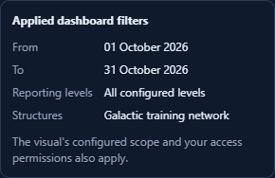
Verify visible criteria and native component filters against the intended source and role.
DashboardVisualsEnabled is disabled by default in its provisioning script. Discovery uses accessible portal/dashboard metadata and rechecks the selected definition, source-query eligibility and supported controls. DashboardVisualsAllowedElementGuids explicitly exposes stable elements for supported inline projection. It grants no portal permission and is not a blanket native-widget exposure list.
Configuration area | Behavior and requirements
Inline projection mappings | Counter; Pie category Full_Description/value Value; Bar category Description/value Value; Line category Description/values Value and Value2; Grid columns. Inline projection additionally needs explicit exposure and compatible metadata.
Native-widget path | Eligible existing controls render through ChatbotPortalWidget.aspx. Source access, definition and filter checks remain required. The frontend normally requests NativeWidget=true.
Source-only cases | Custom-dashboard/special-scope workflows, unsupported controls and ineligible source definitions return a reason and source-dashboard handoff.
Bounded inline results | At most 200 rows, 16 columns and 262144 serialized bytes. Counter reads one row. Limited or incompatible data is not a complete population.
ChatbotPortalFilters prepares card-owned criteria from current metadata. Standard controls can include dates, reporting levels and departments where supported, plus configured dynamic options. A protected context binds user/session, element and definition/filter hashes. Execute requires prepared criteria to match. Handle invalid options, expiry and definition changes by reselecting the visual.
1. Choose a permitted visual and compare its chat title with the source dashboard.
2. Inspect default criteria, change supported controls and apply filters.
3. Open a second card and the source dashboard; confirm neither selection was replaced by the first card.
4. Refresh and exercise a changed-definition or revoked-access case with an authorised test account.
5. Check categories, every series, all table columns and data-view values before cleared captures. Chart-type changes can retain cached values; changing labels alone does not clear private data.
The native scope binds one verified query to one card through HttpContext.Items and restores the previous scope on disposal. It does not overwrite normal dashboard selection/parameter session. Component options, chart/data views, refinement and exports depend on the selected control. Unsupported advanced filtering stays in the source dashboard.
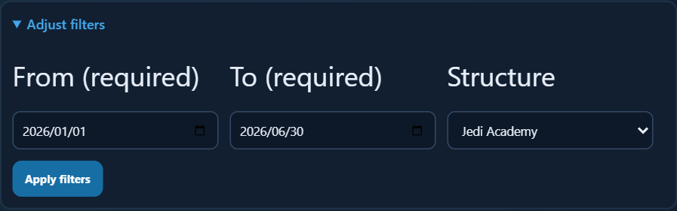
Card filter controls are prepared from the selected source and current permitted options.
Line uses Description with Value and Value2. A returned data table may also include Completion_percent. Available native component options depend on its source control.
- Personal tools, team scope and documents
ChatbotWorkspaceService dispatches a fixed read-only list: team-contact, team-milestones, org-chart, daily-actions, request-tracking, learning, leave-planning, recruitment and hr-followup. It accepts bounded text and employee selection, then delegates to module-specific services. It accepts no generated SQL or client-supplied manager/company scope.
Configuration area | Behavior and requirements
Context and permissions | Verify the signed-in employee mapping. Team, recruitment and HR services retain their roles/module checks. Ambiguous names can require candidate selection.
Workspace limits | Up to 15 candidates, 8 cards and 8 rows per card. Source actions continue to complete module records.
Document gates | DocumentSearchEnabled, PolicyDocumentSearchEnabled and PersonalDocumentSearchEnabled. DocumentSearchMaximumResults fallback 5, bounded 1–10.
Personal verification | Documents/General/ENABLE_SECURITY_VERIFICATION and existing verification session determine whether personal titles/files may be returned.
Latest payslip | Uses the current user’s authorised index and existing payslip service. Preview may need verification or fall back to the normal Payslips page.
Sensitive personal, document and dashboard history restores metadata and requires a current refresh. Conversation history uses browser session storage keyed to the user; it is separate from centrally recorded analytics. This preference is not a global retention or deletion policy.
Normal document/PDF access, employee verification and original module permissions remain outside chat settings. Validate them through existing administration rather than weakening access to make a card visible.
- Reports, builder drafts and leave handoff
Report search uses the user’s accessible catalogue. Preview is bounded and can require the normal viewer when parameters or a source are unsupported. ReportingEnabled is the parent gate; ReportPreviewsEnabled and ConversationalReportBuilderEnabled separately control extensions. Runtime bounds: ReportSearchLimit 6 (1–12), ReportPreviewMaxRows 12 (1–50), ReportPreviewMaxColumns 8 (1–16), ReportDraftMaxFields 6 (2–8).
A report draft is stored in the user session with a random token and a 30-minute maximum age. Opening the visual Report Builder hands off a proposal for review. Returning a draft does not save a report. Preserve source permissions and normal builder validation.
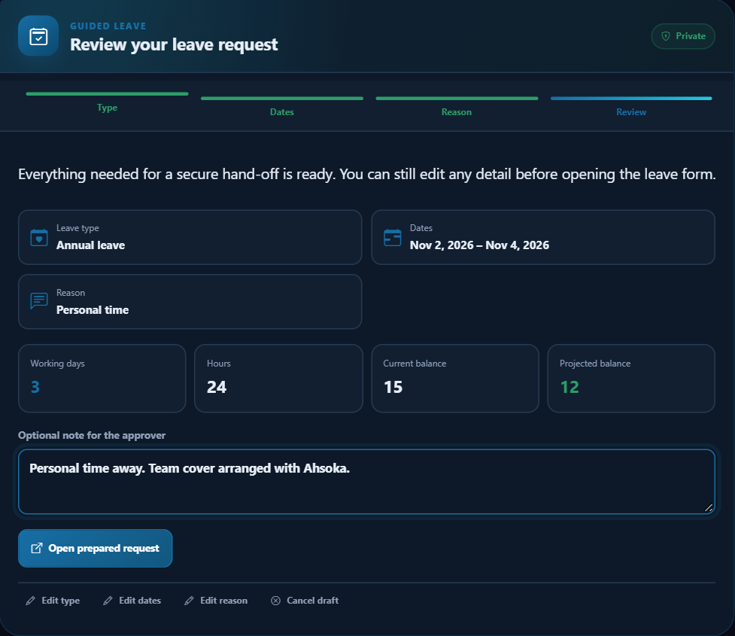
A ready leave draft hands off to the normal secure leave screen for review and submission.
Guided leave collects a bounded draft with type, dates, reason, validation preview and document refresh. Handoff changes draft status to HANDED_OFF and returns a secure request URL. Final leave submission still runs on the normal screen, with calculated values, required documents and existing workflow.
- Support, attachments and recorded evidence
ServiceDeskHandoffEnabled controls optional ticket endpoints. ServiceDesk/General/Version determines the source route. SupportAttachmentsEnabled and chat count/size settings govern the offered attachment experience: SupportMaxAttachments fallback 5, bounded 1–10; SupportMaxAttachmentMB fallback 10, bounded 1–25. Native document-type/library and upload-server limits still apply.
Ticket creation is a business write. The user must deliberately review subject, question, category and attachments before submitting. This guide performs no write. Existing Service Desk assignment, messages and workflow retain their normal implementation.
Interaction, outcome, event and feedback endpoints record supported analytics evidence through installed Chatbot procedures. FeedbackTextLoggingEnabled can suppress stored feedback comments; it does not globally disable question/event logging. Define authorised access, retention and incident response separately. Keep credentials, tokens and real private conversation payloads out of launch material.
Configuration area | Behavior and requirements
Feedback switches | FeedbackEnabled fallback false; Helpful/NotHelpful/Comment/TextLogging fallbacks true. Prompt/label text is configurable.
Source improvement | Ratings identify missing or outdated guidance but do not directly modify Knowledge.
Unavailable dependencies | Retain the implemented unavailable state and source handoff; do not report an error as a successful empty result.
- Analytics and human-reviewed publishing
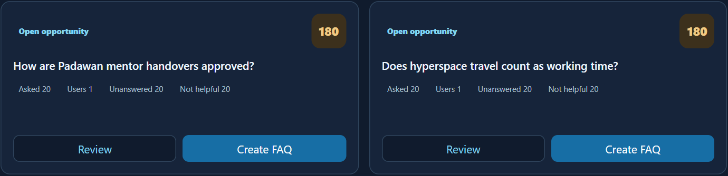
Knowledge opportunities form a review queue; answers are not automatically published.
Open HRFChatbotAnalytics.aspx through the authorised route. AnalyticsEnabled must be enabled and the current user must match AnalyticsAccessUserIds or an exact group in AnalyticsAccessGroups. Lists accept comma, semicolon or pipe separators. Empty access lists do not grant everyone access. AnalyticsDefaultDays fallback 30 is bounded 1–365.
1. Choose the period and available user, answer-source, rating or search filters. Refresh and read counts as recorded interactions, not proven resolutions.
2. Review grouped questions, gaps, feedback and question detail. Distinguish a source gap from access, wording or disabled-tool problems.
3. Open the eligible Knowledge editor. Choose FAQ or Knowledge Article and valid active area/category.
4. Write a draft or request optional AI help only when permitted. Confirm the policy/process with its owner and remove personal details.
5. Save a draft or explicitly publish after review. Re-query as the intended audience, including a negative-access case. Record success only for an authorised completed save.
AnalyticsKnowledgeAuthoringEnabled gates writes. AI drafting additionally requires AnalyticsAIDraftEnabled, AskAIEnabled and System/WebApi/OpenAIEnabled. Each controller action rechecks access. Save permits entry types 1/2, requires title/question/short answer and bounds title 300, question 500, short answer 1500, long answer 8000 and notes/tags 1000 characters. HRF_SP_CHATBOT_KNOWLEDGE_ITEM_SAVE performs the explicit requested draft/publish operation.
AI wording does not validate policy. Editorial work requires an owner, review cadence and a rollback process. Do not promise automatic FAQ generation or answer correctness.
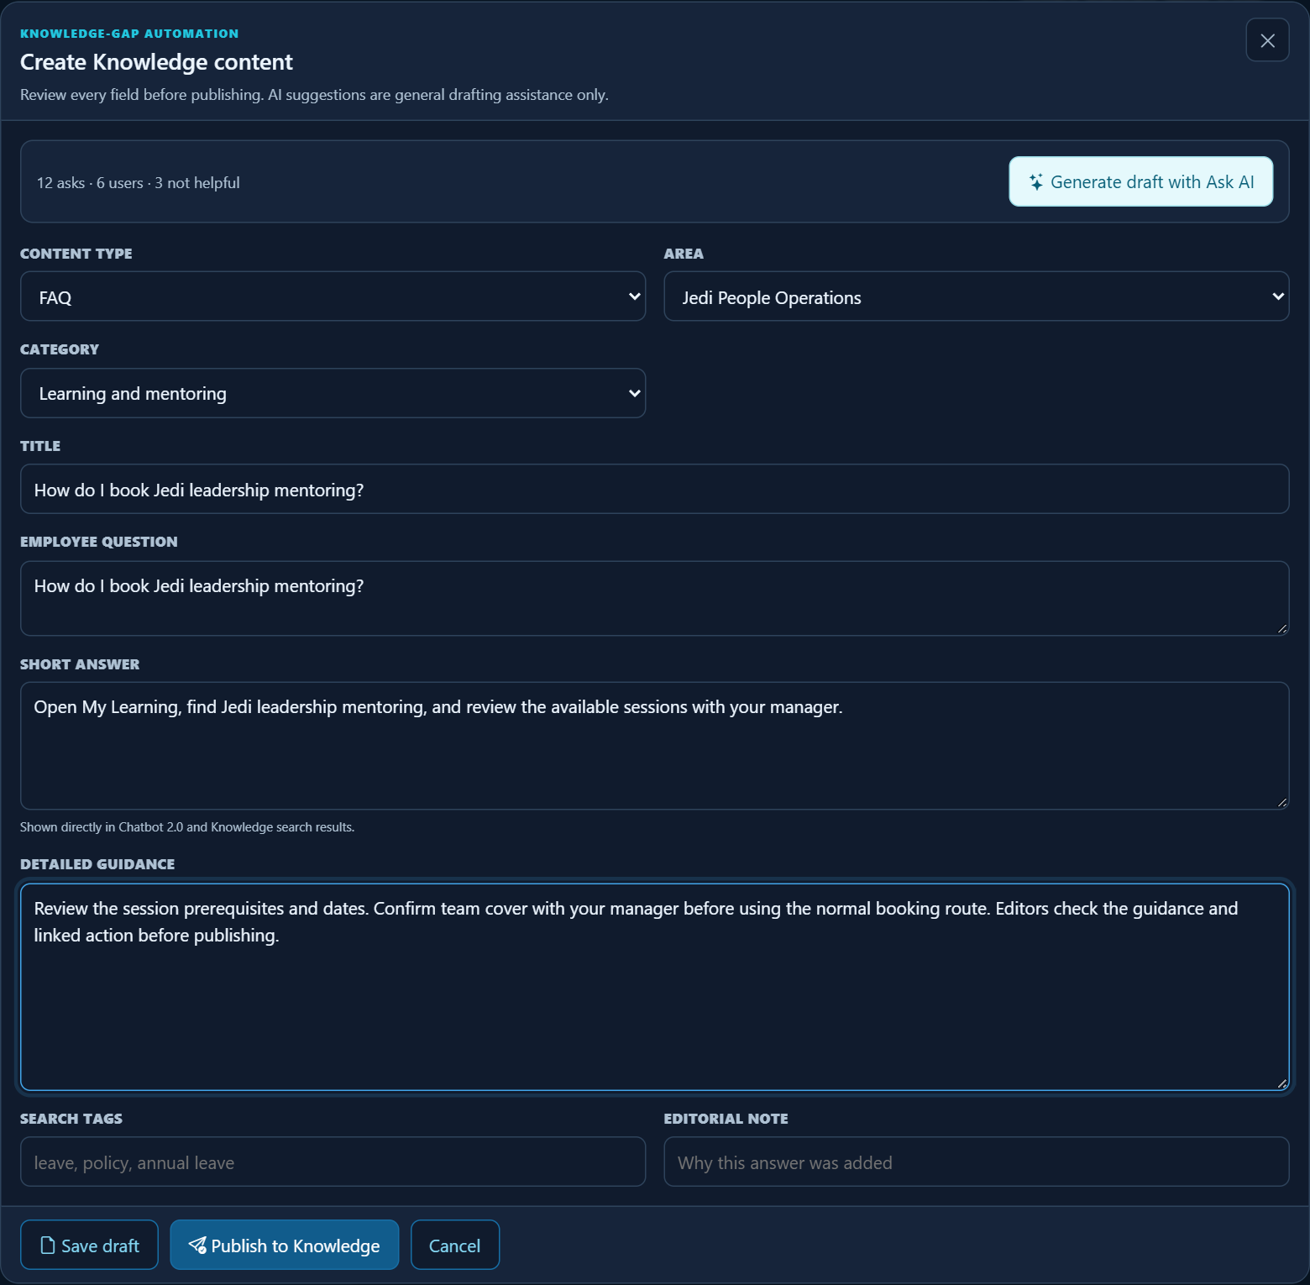
An editor can prepare guidance and choose draft or explicit publication. No save or publish action is evidenced by the image.
- Deployment and targeted verification
Reconcile the installed package before running scripts. Current standard components are grouped under DB/HR/0.STANDARD/003. BO/13. Chatbot 2.0 (Intelligence, Reporting, My Information Catalogue, Documents and Personal Dashboard). Dashboard switches/verification also appear under 003. BO/06. Agents. Analytics portal wiring can appear under 26. HR Analytics. Register references identify inspected files; they do not instruct execution of every release file.
1. Record settings/permissions and use the approved backup and deployment process. Confirm frontend/API assemblies and database objects match the release.
2. Review SQL ordering and existing-value behavior. Intelligence settings can fill blank values and update default/editor metadata; that script is not universally insert-only. Dashboard visual script 905 preserves existing values.
3. Run targeted deployment checks, signed-out rejection and positive/negative role cases.
4. Check Knowledge visibility, own-data context, team selection, document verification, report limits and a source-only dashboard case.
5. Exercise card filters/refresh, history restore, light/dark and mobile. Compare chart/Data values and clear all represented data stores before captures.
6. Perform business-write QA separately for tickets, leave and Knowledge publication; record actual persisted results.
- Troubleshooting and maintenance
Configuration area | Behavior and requirements
Feature absent | Check the exact triplet, configuration cache, fresh bootstrap and effective role/module access.
Visual unavailable or context expired | Reselect it; check source access and definition/filter eligibility. The inline allowlist is not a permission grant.
Personal query empty | Verify employee mapping, approved MyData query and normal module permissions.
AI unavailable | Check both feature gates, server configuration and connectivity without exposing secrets.
Gaps offer no editor | Check analytics access plus the additional authoring and draft gates.
A draft exists but no business record | Complete the normal authorised submission in its source screen.
Maintain reviewed Knowledge owners and source links, measure actual feedback trends and preserve older documentation editions. Recheck settings and access after release or role changes. The companion user guide covers operational tasks; the employee adoption pack intentionally excludes administrator internals.

