My Focus

Chatbot 2.0 User Manual

Prepared by: | HR Focus
Date: | 20 October 2026
Version: | 2026.10.1.0

Table of Contents
1. Start a useful conversation 1
2. Ask clearly and follow the source 2
3. Use personal information and priorities 3
3.1. Use Sources & tools, My dashboard and My insights 4
4. Find documents and your latest payslip 5
5. Ask permission-aware team questions 6
6. Discover an HR dashboard visual 7
7. Filter, refine and refresh a visual 8
8. Read categories, series and columns 11
9. Find reports and prepare a report draft 13
10. Prepare leave and raise Support 14
11. Give feedback and improve Knowledge 15
12. Return safely and troubleshoot 17

Start a useful conversation
HR Copilot brings questions, authorised information and practical next actions into one conversation. Chatbot 2.0 can find reviewed Knowledge, show supported personal and team cards, locate reports and dashboard visuals, and help prepare a handoff to a business screen. Available tools depend on your organisation’s configuration and your current access.
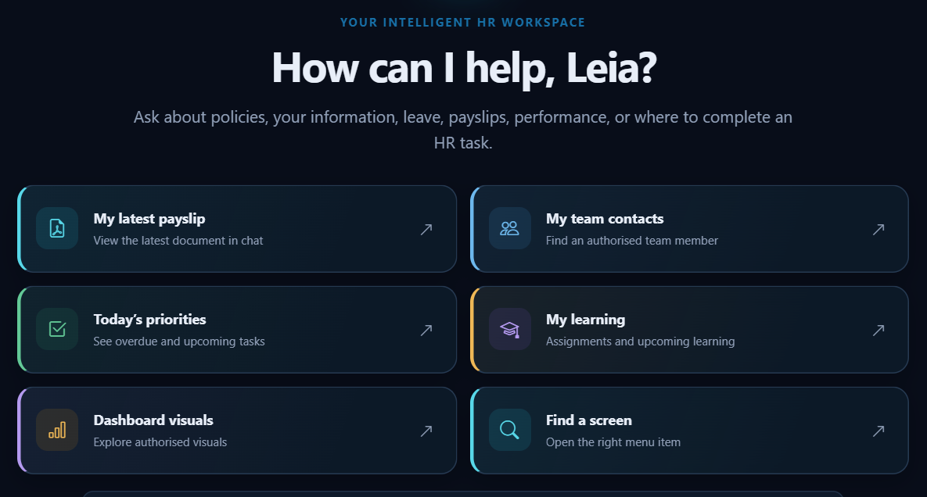
Leia’s task-based starting questions offer personal information, team tools and dashboard discovery.
1. Sign in to My Focus using your own account. Open the configured HR Copilot or Chatbot entry. Menu wording can vary.
2. Choose a suggested question or type one clear task in the message box. Try “What needs my attention today?”
3. Read the returned answer or card, including its source, criteria and freshness message. Choose the next action that matches your task.
4. If a result needs a choice, select the intended employee, report or dashboard visual after reading the available names.
5. Use New conversation when changing topic. Use the available theme and panel controls to make the workspace comfortable on your screen.
- Ask clearly and follow the source
Start with a subject and the action you need. “Find the leave policy” is clearer than “Help”. A date, document title or employee name can make a supported search more useful. The assistant recognises supported tasks and searches configured sources; arbitrary phrasing does not create a report or a business rule.
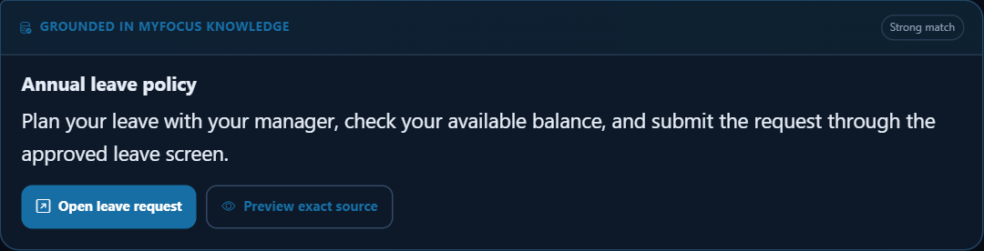
A grounded answer retains a source handoff so the reader can check the underlying guidance.
1. Ask a single question, such as “What is my current annual leave balance?”
2. Read the source label, returned values and links before acting. Knowledge guidance, a personal card and an AI response have different origins.
3. Open the source preview when available, then the source page for the complete policy, report or transaction.
4. If an answer is incomplete, rephrase with the relevant topic or choose a suggested follow-up. Confirm an important decision against its authoritative source.
5. Use Helpful or Not helpful when offered. Add a short explanation of what was missing without unnecessary personal details.
Ask AI and a connected assistant are optional services. Review generated text against your employer’s policy. The normal business screen remains the authority for decisions and submissions.
- Use personal information and priorities
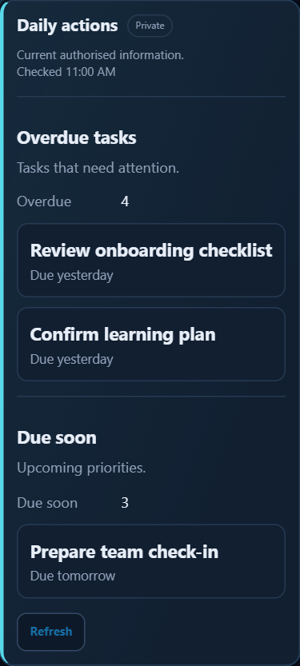
Daily actions brings supported tasks and approvals into a read-only card with source actions.
Personal tools use your signed-in employee context. They can show supported current information, priorities and module summaries. A card is a bounded summary; use its available action to continue in the source application.
Task or question | How to use the result
“What needs my attention today?” | Review returned tasks and approvals, then open the relevant action.
“Show my current personal information” | Check the returned fields and use the normal personal-details screen for permitted changes.
“Show my learning and certificates” | Review the supported learning rows and open Learning for the complete record.
“Track my claim status” | Read the request-tracking summary, dates and source action.
1. Start with your own information.
2. Check the card title and snapshot or freshness notice.
3. Use Refresh on a supported card for a new lookup. A restored conversation may require a fresh check.
4. Open the source action for the complete record, a correction or an approval.
  - Use Sources & tools, My dashboard and My insights
Open the Sources & tools panel for Grounding, My insights and My dashboard when enabled. Grounding keeps sources and suggested actions near the conversation. My dashboard combines supported private employee, workflow and payslip summaries, including inbox/outbox/task/alert counts and payslip-year bars. Its CSV and copy actions export the loaded summary; check it before sharing. This personal panel is distinct from choosing a Dashboard Portal visual in a chat card.
My insights shows recorded question, feedback and gap measures with repeated questions where enabled. Its self-service percentage is an interaction measure, not proof that every issue was resolved. Open the normal module for complete operational information.
- Find documents and your latest payslip
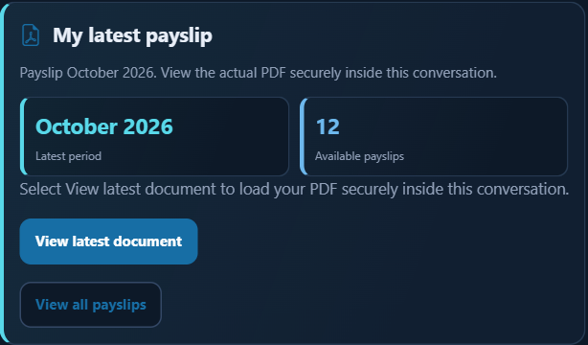
The latest-document experience provides a permitted document action and a fallback to the normal document screen.
1. Ask “Show my latest payslip” or “Find my training certificate”. For guidance, ask “Find the leave policy”.
2. Read whether the result is personal, a policy document or unavailable. Choose the intended title.
3. If identity verification is required, complete it on the secure Personal Documents screen. Return and retry the lookup.
4. Use the offered preview or open action. If the latest document cannot be shown here, use All payslips or the offered source screen.
5. Check the period or updated date. Close a preview when finished and keep private records on your own screen.
Document search reuses your authorised document index and verification requirements. No match may mean there is no matching indexed document, access is unavailable, the feature is disabled, or verification is outstanding. It does not prove payroll has not produced a payslip.
- Ask permission-aware team questions
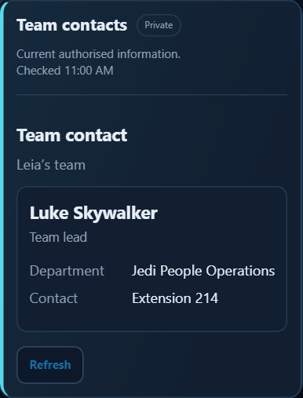
Luke’s permitted contact card is returned in Leia’s team context.
Task or question | How to use the result
“Find contact details for Luke Skywalker” | Select the correct person if a candidate choice appears; read only permitted fields.
“Show my team’s upcoming birthdays” | Review the permitted milestones and displayed period.
“Show my reporting structure” | Use the supported reporting-structure card or source action.
“Who in my team is away?” | Read the leave-planning summary and open the normal leave view for full detail.
1. Name the task and, when appropriate, the employee.
2. Select the correct candidate rather than repeatedly broadening a name search.
3. Read the returned scope and dates. Manager and HR access can differ.
4. Refresh if reporting relationships or your role recently changed. Ask an administrator if expected access remains unavailable.
Team cards follow existing role and module rules. They do not replace manager, HR or personal-document permissions. A task may return only your own information or a source action. Keep contact, leave and HR information within its business purpose.
- Discover an HR dashboard visual
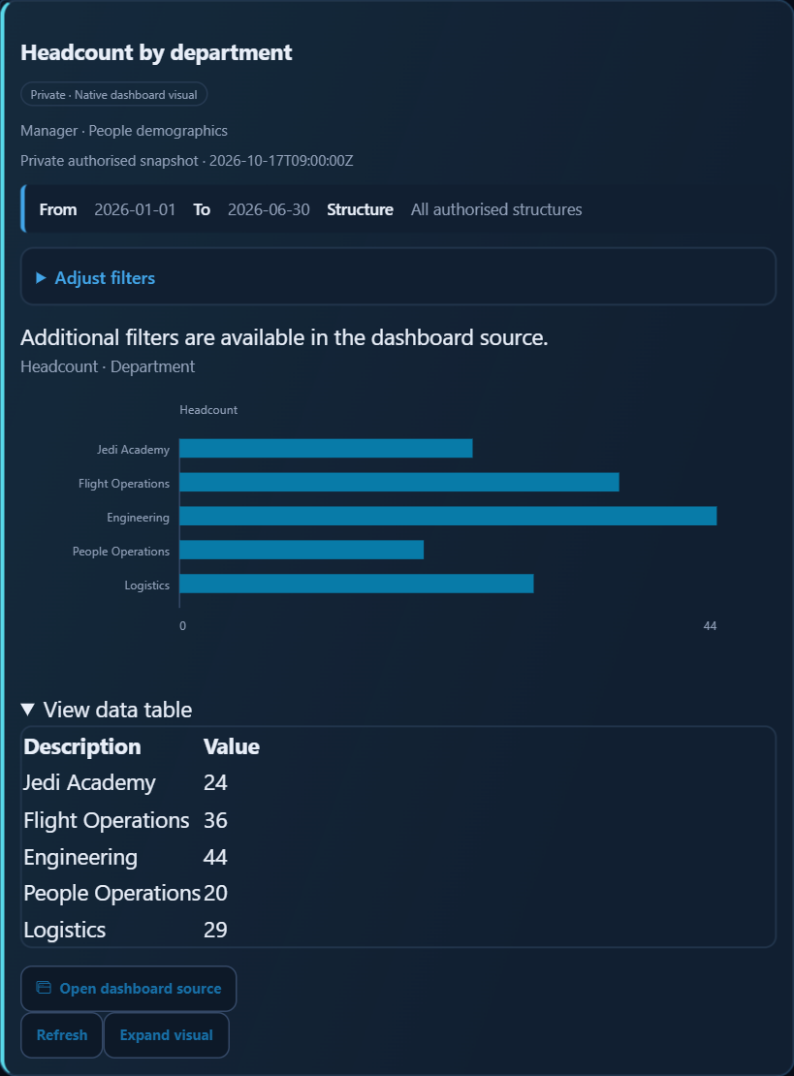
Headcount by department: five categories, one count series and the matching data table.
Ask for an existing visual: “Show dashboard headcount charts” or “Show employee demographics”. Read the dashboard and portal names before selecting the result. Data comes from an existing configured source, subject to your access. Asking for arbitrary measures does not create a new source.
1. Ask for the dashboard topic.
2. Read the matching titles and source names. Choose Select visual.
3. Wait for access and filter checks; read the criteria above the result.
4. Use Expand visual when more room is needed, then restore the card.
5. Open the dashboard source when a component or additional filters are unavailable inside chat.
In this worked headcount result, Jedi Academy has 24 people, Flight Operations 36, Engineering 44, People Operations 20 and Logistics 29: 153 across five categories. Compare the chart with the matching Description and Value columns.
- Filter, refine and refresh a visual
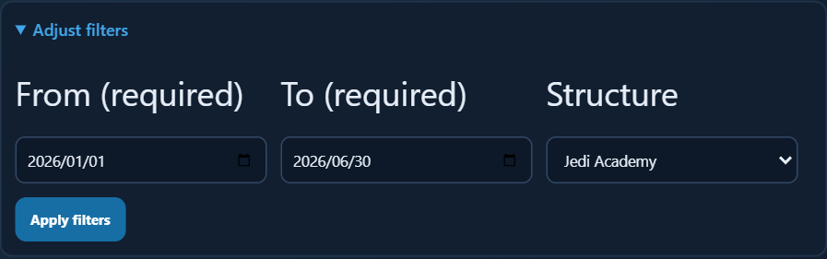
Adjust filters: choose the period and permitted structure, then Apply filters.
1. Open Adjust filters on the chat card when available. Choose supported dates, reporting levels, departments or configured options.
2. Select Apply filters. These criteria belong to this chat visual. Other cards and the source dashboard keep their own selections.
3. Use the native component’s available filtering, refinement, chart-options and Data controls to inspect the result. Controls vary by component.
4. Use Refresh to request current access and data. Refresh does not approve a transaction or publish a report.
5. Reselect the visual if its definition, permission or context changed. Open the dashboard source for advanced filters and the complete presentation.
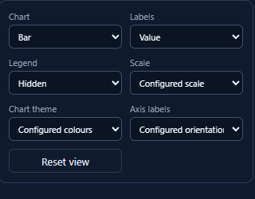
Chart options belong to the native component; the offered styles depend on its implementation.
A presentation change does not create extra data. Department is a category; employee count is a series. A table can carry descriptive columns that are not measures. Use Data view to check values before comparing trends.
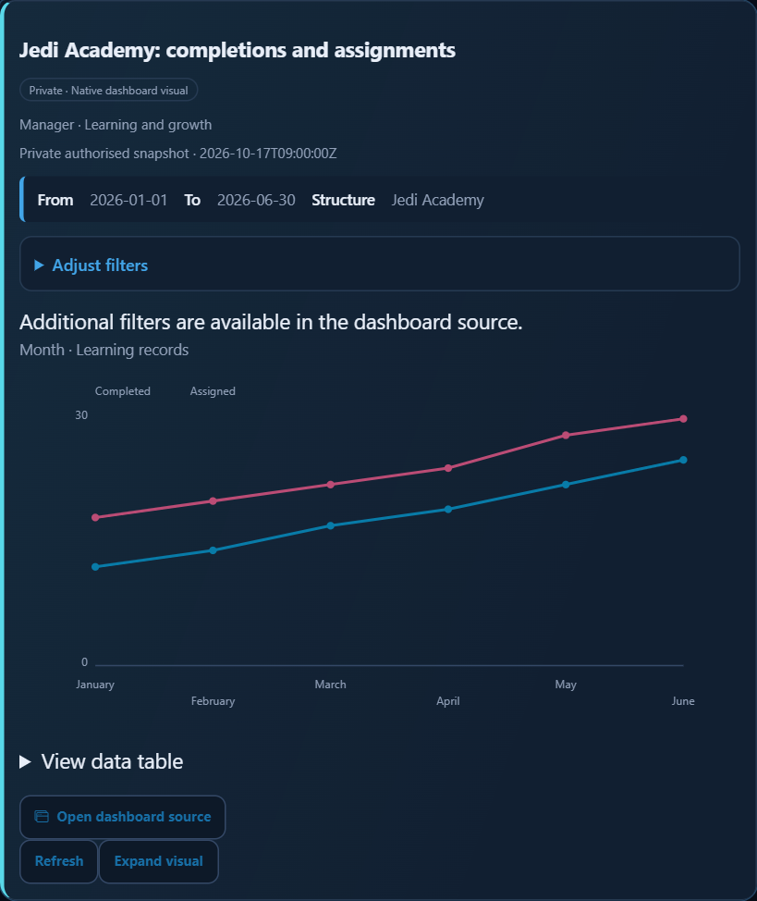
Applied Jedi Academy criteria change the returned learning result. Refresh requests a new lookup using the card context.
- Read categories, series and columns
The learning comparison below uses six month categories and two named series: Completed and Assigned. View data table exposes Description, Value, Value2 and Completion_percent. Read the legend to relate Value to Completed and Value2 to Assigned.
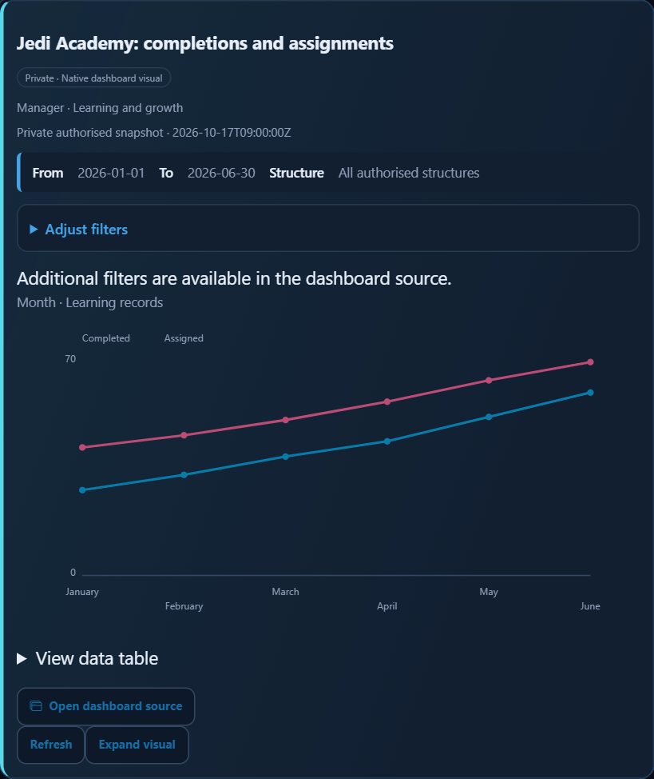
Learning trend: January–June categories and two numeric series.
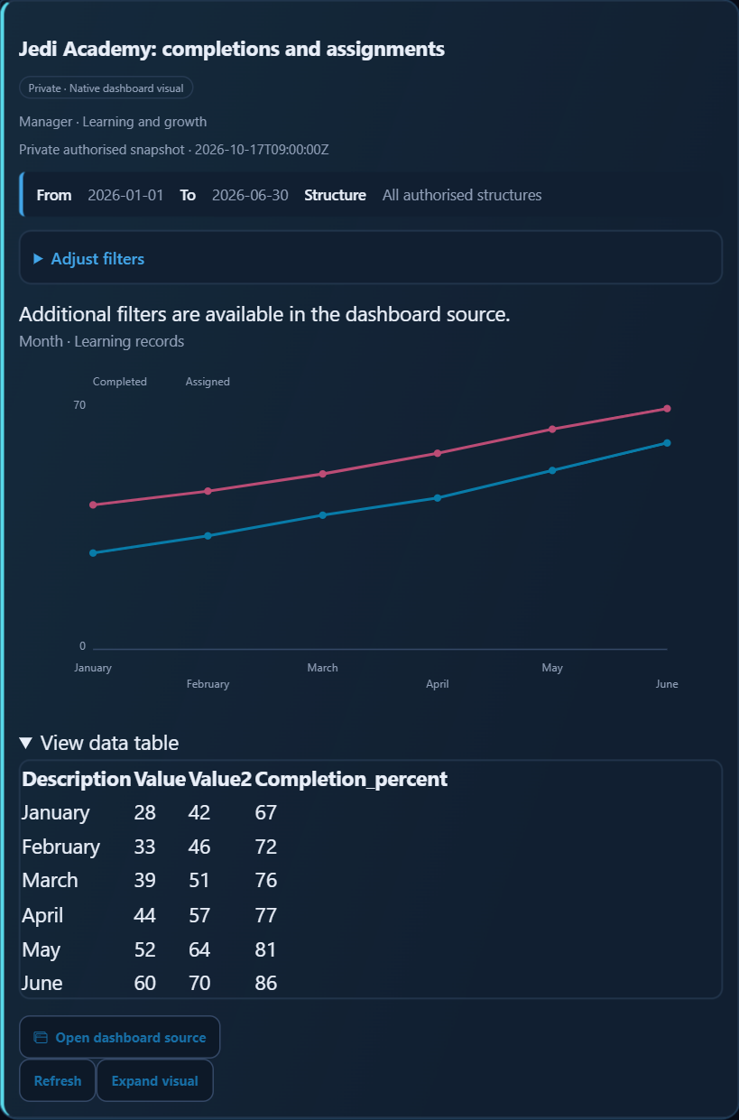
The same learning result exposes four columns for inspection.
Month | Completed / Assigned / Completion percent
January | 28 / 42 / 67%
February | 33 / 46 / 72%
March | 39 / 51 / 76%
April | 44 / 57 / 77%
May | 52 / 64 / 81%
June | 60 / 70 / 86%
For these worked values, June has 60 completed learning records and 70 assigned; the displayed completion percentage is rounded to 86%. Do not add percentages across months. These are two series over time, not two independent workforce totals.
Applying the Jedi Academy structure returns Completed 12, 14, 17, 19, 22, 25 and Assigned 18, 20, 22, 24, 28, 30 for the same six months. June becomes 25 of 30, rounded to 83%. Compare like periods and inspect the new criteria before comparing scopes.
- Find reports and prepare a report draft
Report discovery searches reports available to your account. It can offer a report, a bounded preview or the Report Portal. Reports needing parameters may require their normal viewer. A conversational draft is a starting point for the visual Report Builder, not a saved or approved report.
1. Ask “Find leave reports” or another specific topic.
2. Read the titles and indicated module or visibility. Open the intended report.
3. If Preview is offered, inspect its limited rows and columns. Use the source viewer for required parameters and full results.
4. For an enabled draft action, describe supported fields and purpose. Review the proposed source, fields and chart type.
5. Open the Report Builder to continue. Verify access, filters, layout and data before saving through its normal workflow.
A small preview may be truncated and cannot establish a full population count. Previews, inline report charts and draft building are configurable. Source permissions still apply.
- Prepare leave and raise Support
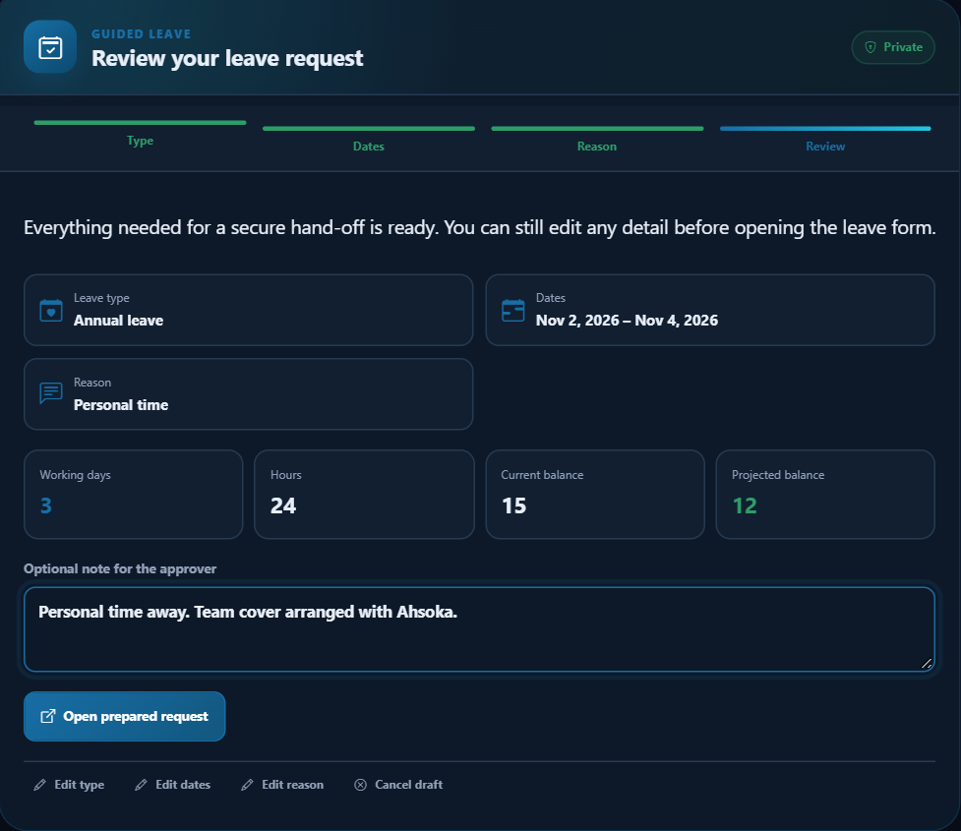
Guided leave prepares details for the secure leave screen; submission remains on that screen.
1. Ask “I want to go on holiday next week”.
2. Choose an available leave type, supply dates and provide a reason when requested. Read validation and calculated preview values.
3. If documents are required, use the secure upload action and Refresh documents.
4. Open the secure leave request screen. Review calculated values and attachments, then use its normal submit action.
5. Confirm submission and workflow status on the leave screen. Prepared or handed-off chat details are not submitted leave.
Use the Support handoff for an unresolved HR or IT question when enabled. Review subject and details, select the correct category and add necessary attachments before deliberately submitting. The Support action can create a ticket. Check any failure message rather than assuming it succeeded.
If no handoff is offered, use the normal Support menu. Include the task, screen, error and useful reference. Avoid copying unnecessary payslip or private employee information into a general request.
- Give feedback and improve Knowledge
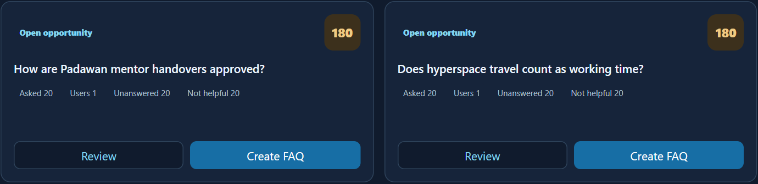
Authorised editors review recurring unanswered questions and feedback as editorial opportunities.
Helpful feedback identifies useful guidance. Not helpful comments can explain an outdated policy detail, missing step or unclear next action. Feedback does not directly rewrite a Knowledge article.
1. Read the answer and source before rating it.
2. Choose Helpful or Not helpful when enabled.
3. If a comment is offered, name the missing or incorrect detail briefly. For example: “Add the current certificate-request steps.”
4. An authorised editor reviews grouped questions and feedback, verifies an answer with the policy owner and explicitly saves or publishes reviewed content.
5. After the organisation confirms a correction, ask again and check the revised source.
Optional AI drafting can help an authorised editor start wording. It does not validate policy or publish automatically. Questions, ratings and comments may be recorded for authorised service improvement; follow your organisation’s privacy guidance.
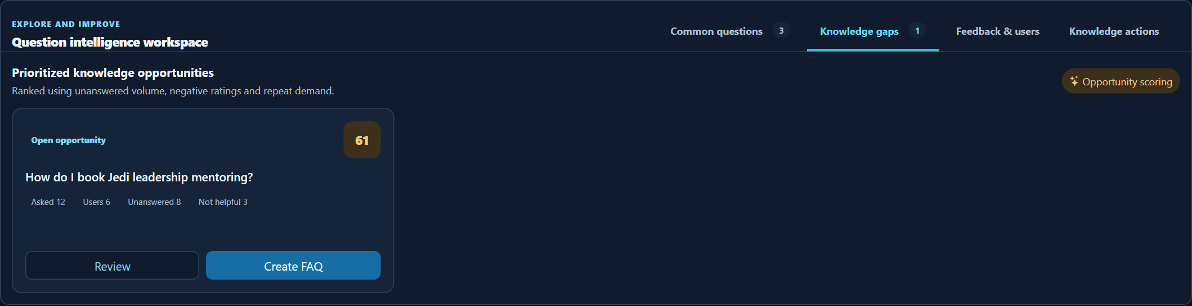
A recurring mentoring question can be selected for editorial review.
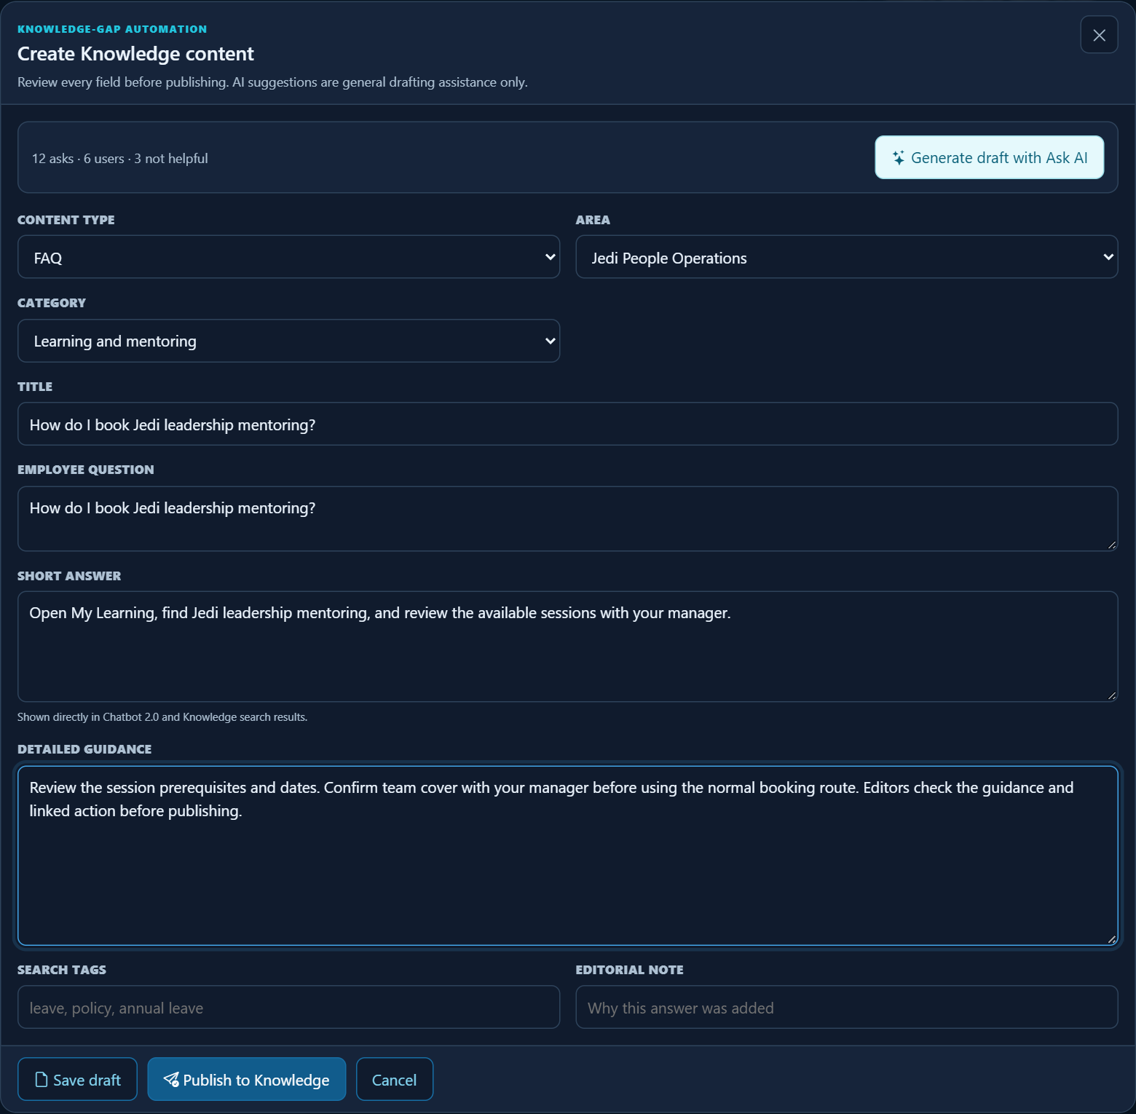
Knowledge editor with human-prepared wording and explicit Save draft/Publish controls. The illustration does not show a completed save.
- Return safely and troubleshoot
Task or question | How to use the result
The card is restored or old | Use Refresh. Sensitive cards may restore metadata only and need a current access check.
There is no matching result | Try a specific supported topic; use the normal module and report a genuine source gap through Support.
A dashboard component will not load | Read the message, reselect it or open the source. Eligibility and filter support vary.
A personal document will not open | Complete normal verification and retry; use the offered source fallback.
Prepared leave is absent from requests | Complete the normal secure-screen submission and check its final request status.
The session expired | Sign in again through the normal route and repeat the lookup.
New conversation clears the current saved conversation in this browser session. It does not erase centrally recorded interactions or feedback. Close private previews and sign out when leaving a shared computer.

