My Focus

HRFSupport User Manual

Prepared by: | HR Focus
Date: | 20 October 2026
Version: | 2026.10.1.0

Table of Contents
1. Start with the right workspace 1
1.1. Open Support and orient yourself 1
2. Find and understand your tickets 3
2.1. Search, filter and sort 3
2.2. Read the headline measures 3
3. Create a useful new request 5
3.1. What must be complete 5
3.2. Write a request that an agent can act on 6
4. Attach evidence and confirm the save 7
4.1. Add files with descriptions 7
4.2. View and remove an attachment 8
4.3. Handle partial success 8
5. Read details and update an existing request 9
5.1. Read the conversation correctly 9
5.2. When no update action is available 10
6. Work the assigned support queue 11
6.1. Intake and ownership 11
6.2. Internal and public feedback 11
6.3. Reassign to the right support line 12
7. Create a request on behalf of an employee 14
7.1. Confirm the person before submitting 14
7.2. Keep the communication useful 15
8. Resolve, close or cancel with a clear outcome 16
8.1. Reusable common solutions 17
9. Use FAQ and improve Knowledge deliberately 18
9.1. Get an existing answer first 18
9.2. From repeated questions to a reviewed answer 18
10. Export a branded Excel workbook and troubleshoot 21
10.1. Choose the layout for the download 21
10.2. Quick troubleshooting 22

Start with the right workspace
HRFSupport brings personal requests and assigned support work into one Support Intelligence Workspace. Use My Tickets for requests associated with you. Use Assigned Tickets for the support work made available to your user through the configured workflow and access rules. The organisation controls which menu entry opens Support and which optional services are enabled.
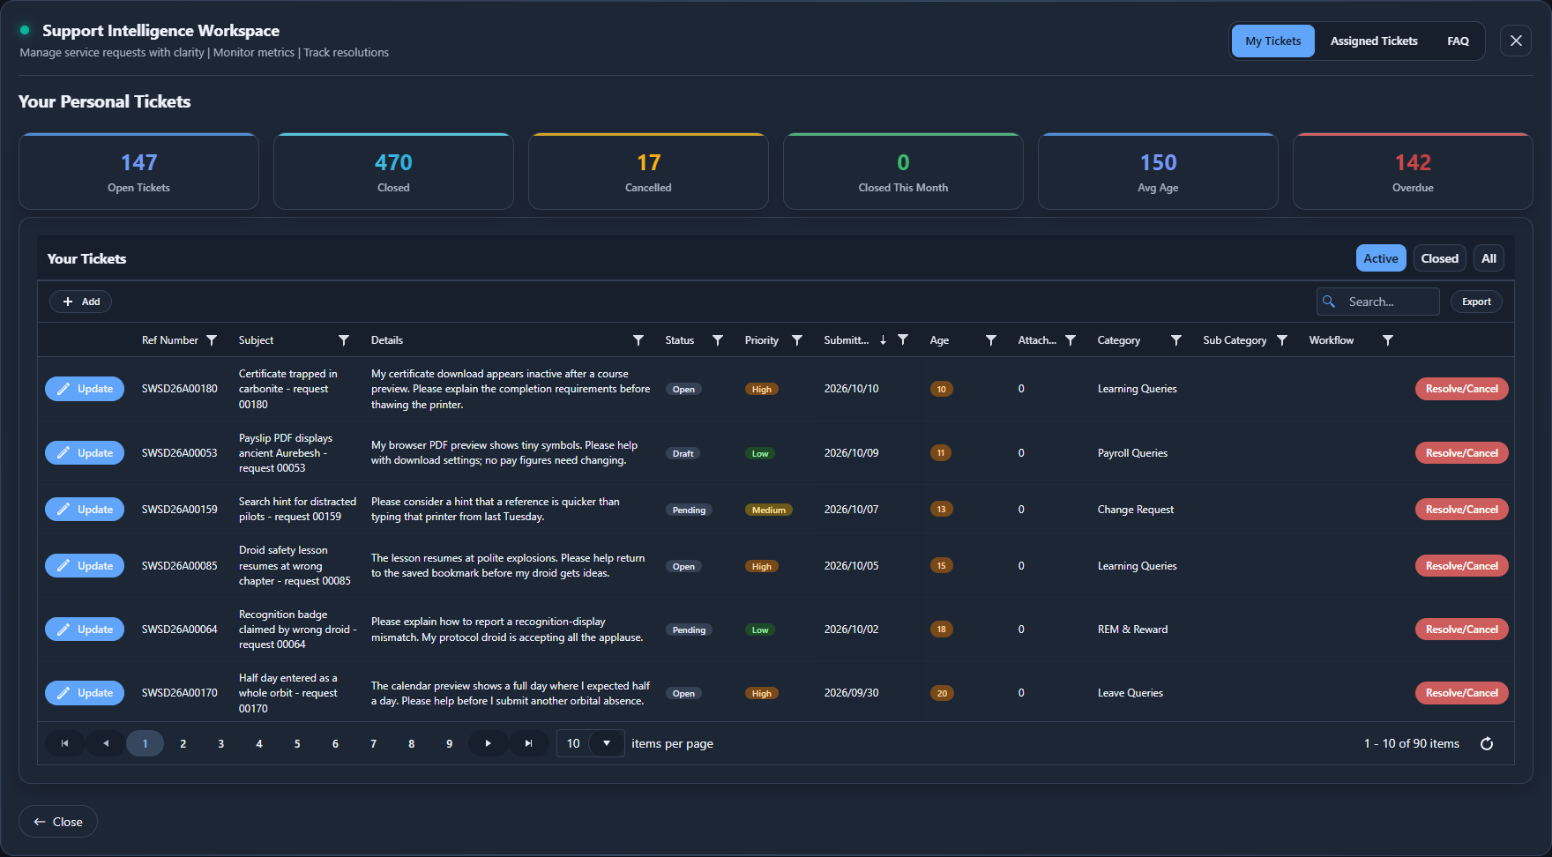
My Tickets: personal scope, status selection, measures and the ticket list.
  - Open Support and orient yourself
1. Sign in to My Focus and open the configured Support or Service Desk menu entry. The modern workspace is HRFSupport.aspx; the displayed menu wording may vary.
2. Select My Tickets or Assigned Tickets before searching. A view change changes the scope of the loaded list.
3. Choose Active, Closed or All. Use the reference number when returning to an existing request.
4. Use FAQ to look for an existing answer before opening another request. In the standard host this opens the shared FAQ experience.
5. Use Close to return to the configured home page. In an embedded host the close buttons may be intentionally hidden.
If you cannot see expected work, first check the selected view and status. Support membership, workflow routing and current assignment affect the assigned list. A visible Assigned Tickets tab is not a promise that every employee has support access. Ask the support administrator to check your effective access rather than sharing another person's account.
- Find and understand your tickets
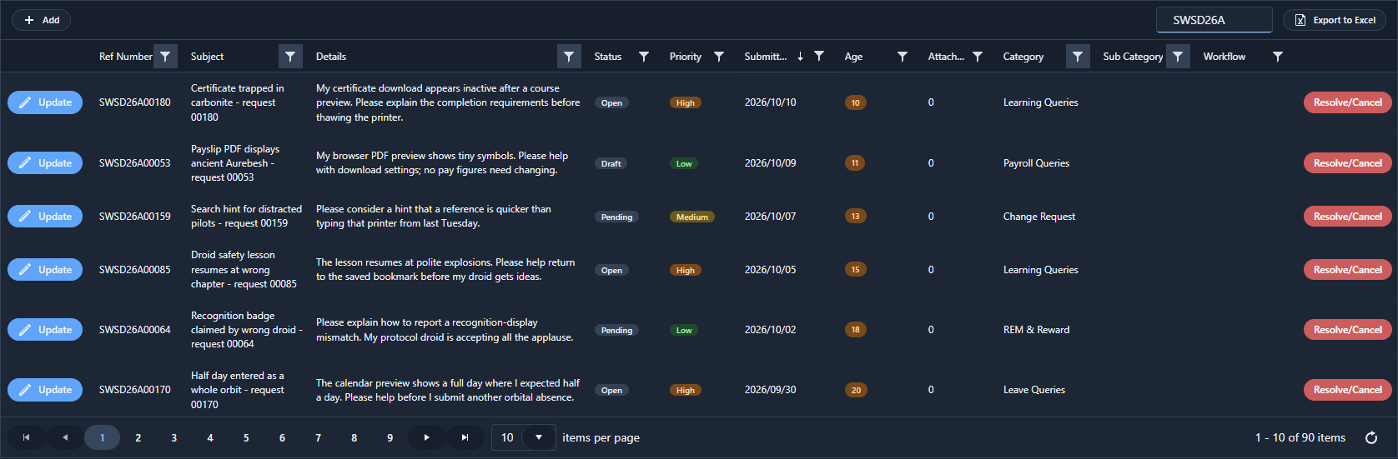
A ticket grid combines reference, status, priority, category and dates with row actions.
  - Search, filter and sort
1. Choose the view and status range you need. Active covers Open, Pending and Draft; Closed covers Resolved, Closed and Cancelled. All includes both sets.
2. Enter a reference or useful words in the grid Search box. For example, search for a printer, course certificate or leave-balance question.
3. Use a column filter when you need a particular category, status or date. Check that an earlier filter is not hiding the ticket.
4. Select a column heading to sort. Resize or reorder columns when a longer subject needs more room. Use paging controls and the page-size selector to review further rows.
5. Refresh after a save or when another agent may have changed the work. Recheck the current view and filters before concluding a request is missing.
  - Read the headline measures
The tiles summarise the loaded ticket scope: open/active work, closed work, cancelled requests, closures or resolutions this month, average age and overdue work. They help you decide where to look first; a column search does not necessarily redefine those summary totals. Average age is a duration, not a promised response time. Overdue is the workspace's age indicator and does not replace an agreed service-level policy.
Status | Meaning and next action
Open (O) | The request has been recorded and remains active. Add missing facts through the update action.
Pending (P) | The request is waiting for information or a dependency. Read the latest public feedback before responding.
Draft (D) | The record remains in the active set. Follow the available action and your organisation's submission process.
Resolved (R) | A resolution has been recorded. Read the outcome and use the permitted follow-up route if further help is needed.
Closed (CLD) | The request is complete and appears in the closed set.
Cancelled (C) | The request was withdrawn or stopped. It remains available as a record.
- Create a useful new request
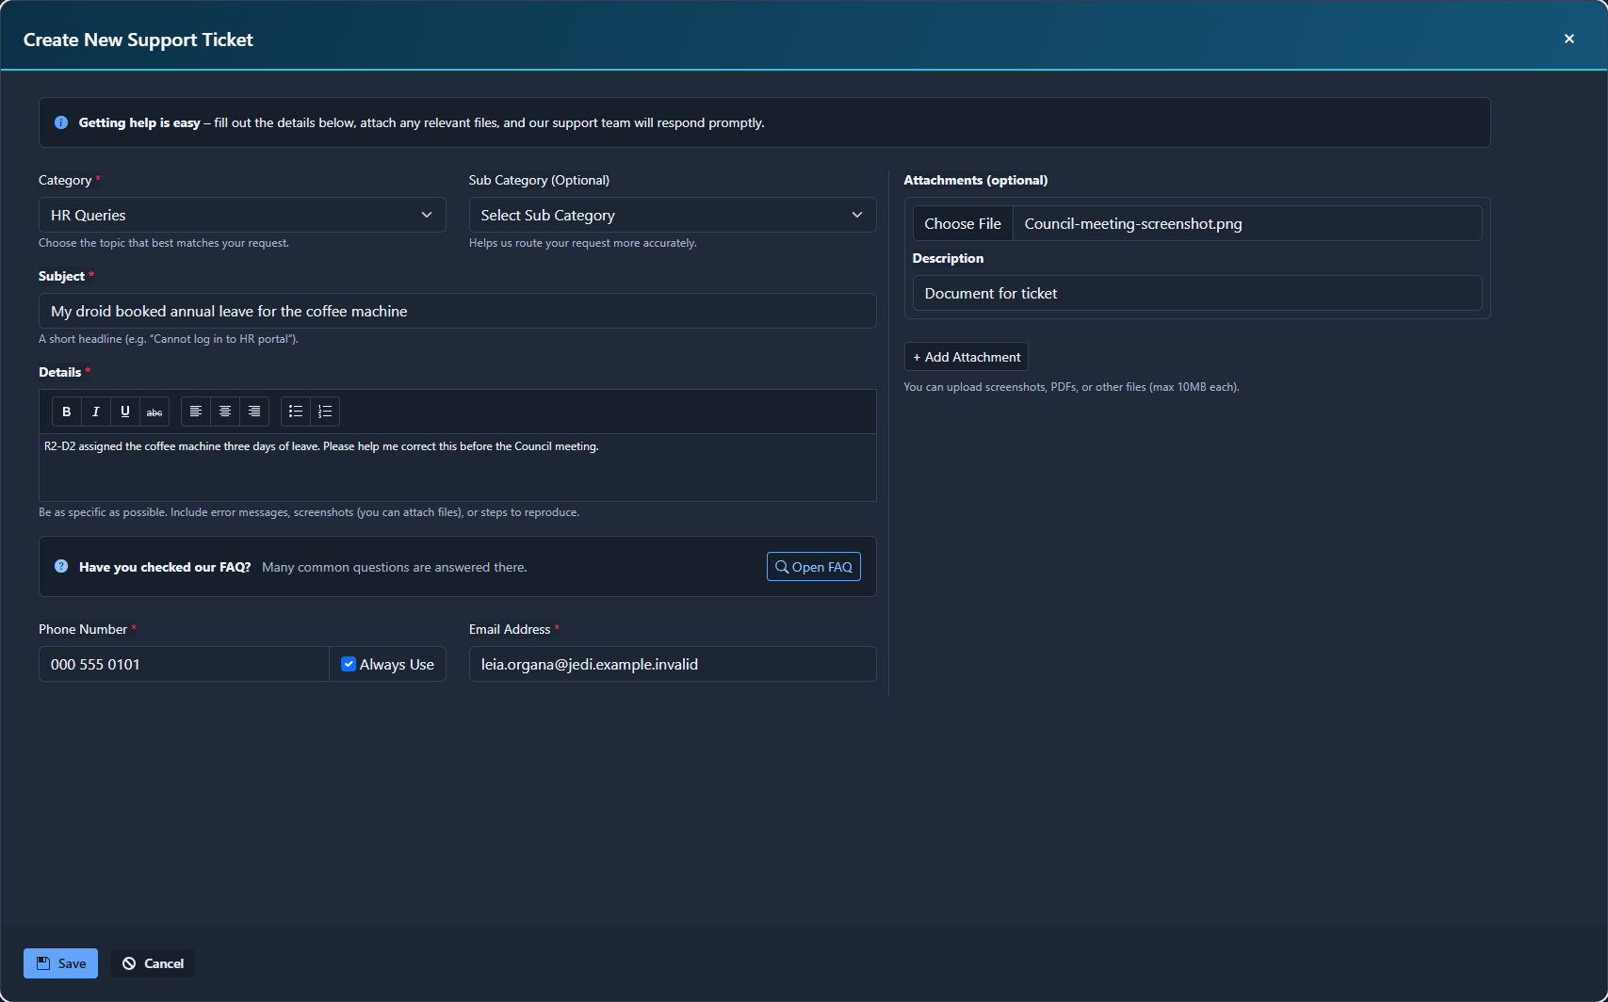
New request form: classification, description, contact details and optional attachments.
1. In My Tickets, choose Add new record or the available create action.
2. Select the most suitable Category. If the category has subcategories, select the one that best describes the issue.
3. Write a short Subject that names the problem and affected function. Add the steps, expected result, actual result and when the issue happened in Details.
4. Check Phone Number and Email Address. The email is pre-filled and read-only when one is already available; contact your administrator if that source address is wrong. Enter a valid email when the field is blank.
5. Read FAQ or any possible common solutions shown for your subject/category. Use an answer only after checking that it fits your situation.
6. Add relevant attachments and clear descriptions, then submit once. Wait for the saved reference and any attachment result before closing the window.
  - What must be complete
Category, Subject, Details, Phone Number and Email Address are required in the personal create form. A subcategory depends on the category options. Correct the highlighted field and submit again if validation reports a problem. Personal users do not choose the operational priority: the organisation's configured default applies.
  - Write a request that an agent can act on
A useful subject is "Certificate download unavailable after completing course", followed by the course name, completion date, the button selected and the message shown. "It does not work" gives the agent little to investigate. Include enough context to reproduce the issue, but keep passwords, authentication codes and unrelated employee information out of the description and files.
The Always Use checkbox is available beside the phone number. Treat it as the request's contact preference; it does not guarantee an update to the employee's master contact record. Keep your formal contact details current through the organisation's normal employee-information process.
- Attach evidence and confirm the save
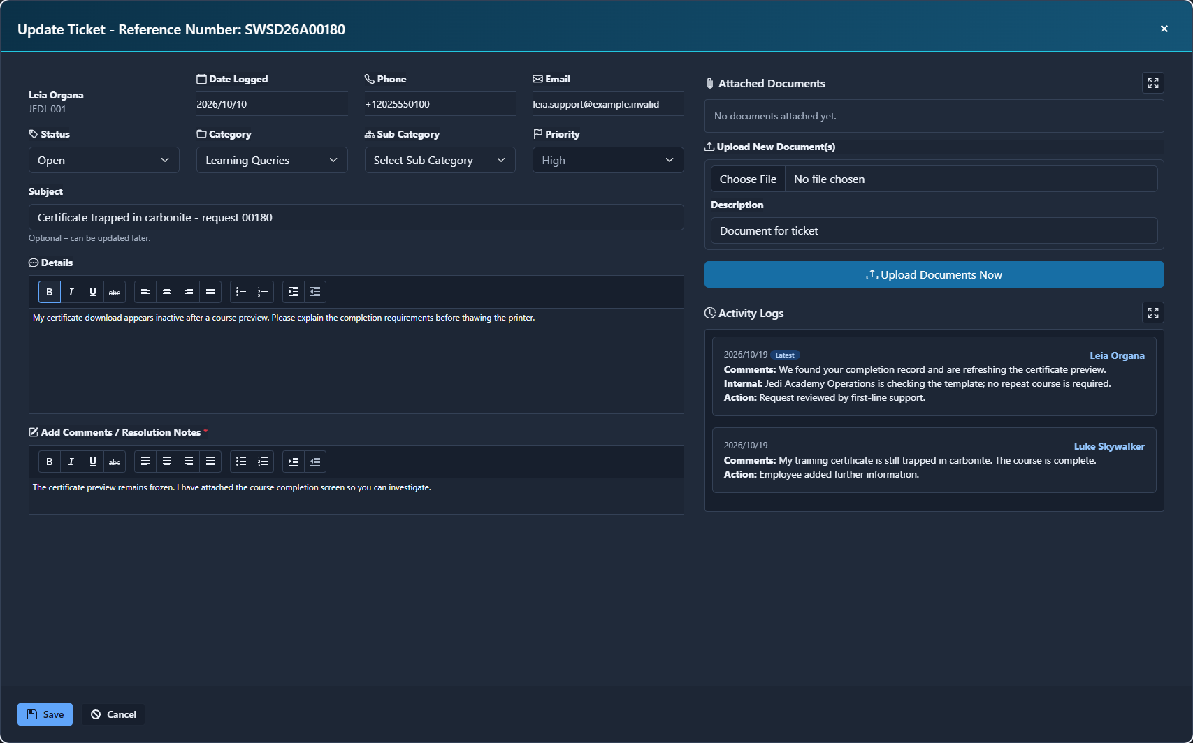
The update window provides attached documents, an upload area and descriptions alongside the ticket.
  - Add files with descriptions
1. Choose a file in the attachment panel. Give it a description that explains what the agent should look at.
2. Choose + Add Attachment for another file. Remove a row you no longer need before submitting.
3. Prefer a focused screenshot or PDF of the relevant message. Check that it contains only the information necessary for this request.
4. Submit the ticket and read the result. The ticket is saved before the attachment upload completes, so an upload warning can occur even when a reference has been created.
5. Open the saved ticket and check Attached Documents. If a file is missing, use the available attachment action on that saved ticket rather than creating a duplicate request.
The new-request form displays a maximum of 10 MB per file. Actual acceptance also depends on the installed upload handler, document-library configuration and the web server's request limits. A batch of files can exceed the total request limit even if each file is below the displayed per-file guidance. Ask your support team about approved types and size limits; do not assume every file type is accepted.
  - View and remove an attachment
Open the ticket's documents area and choose the document link to view it through the document viewer. Use Expand when you need more room. Where a remove action is available, confirm that you are removing the intended attachment. A missing or unavailable action may reflect the ticket state or your access; ask the agent to help rather than attempting to change a document link.
  - Handle partial success
If the request saves but one or more files fail, retain the reference and the upload message. Reopen the record to check what is already present. Report the file name, approximate size and the time of the attempt without resending sensitive content through an unrelated channel. If the session has expired, sign in again and check for the saved reference before repeating a submission.
- Read details and update an existing request
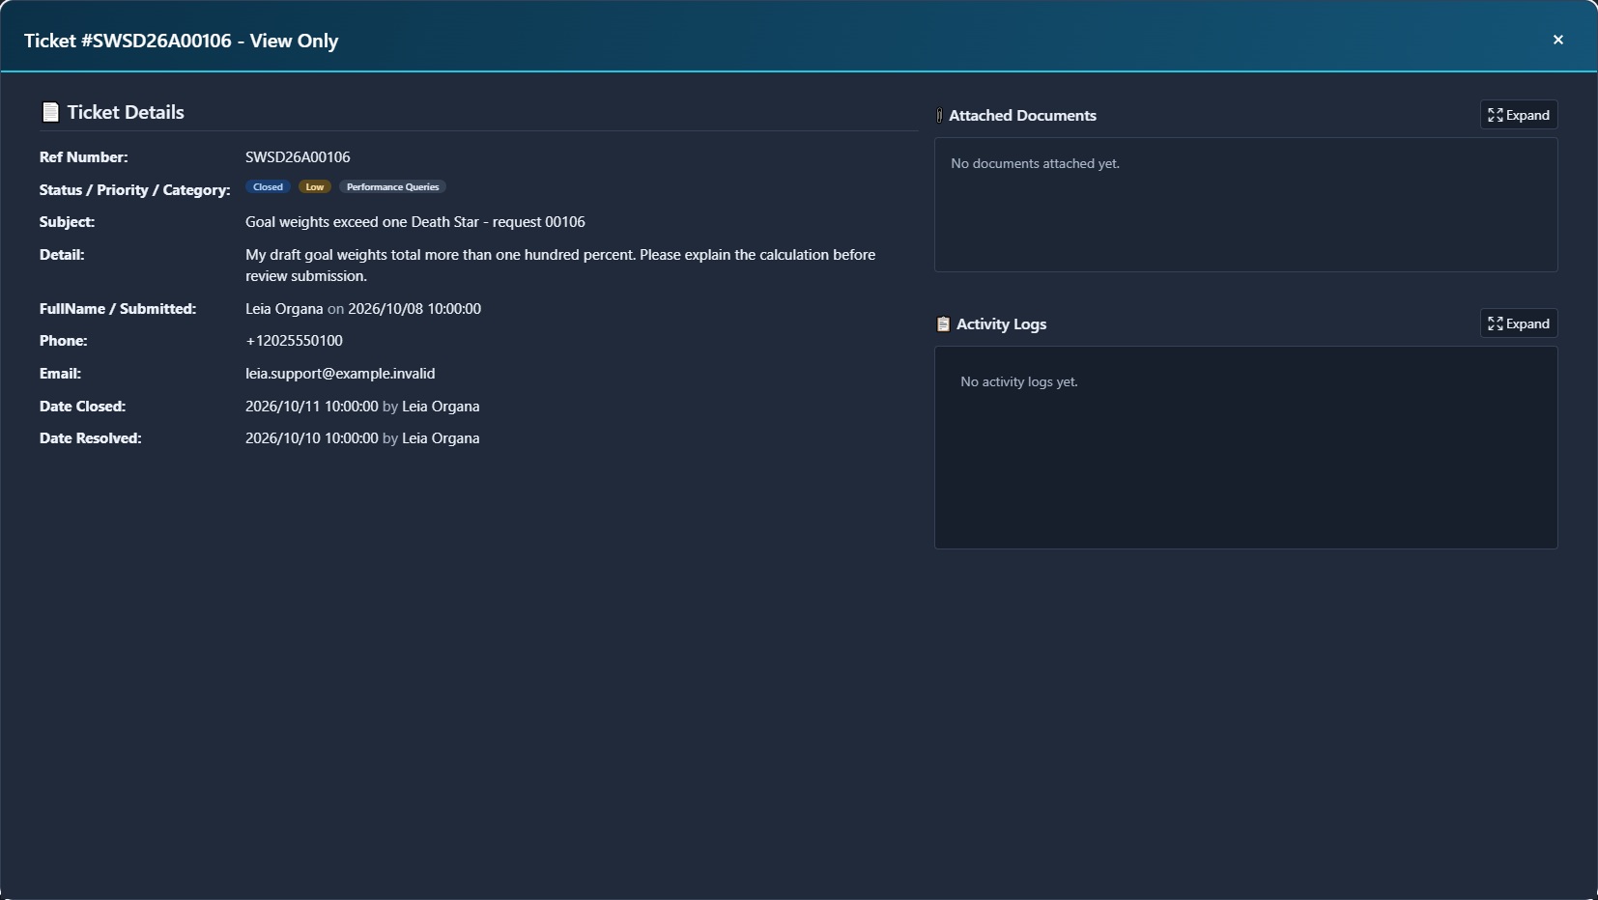
Ticket detail shows the description, submission and completion dates, attached documents and activity logs.
1. Find the reference in My Tickets and select the available View or Update action. A View Only heading means the window is for reading.
2. Review the subject, current classification, status, priority, contact details and latest history before editing.
3. Use the update form to add the new facts the support team needs. Preserve useful earlier context rather than replacing it with a short "still broken" message.
4. Check any additional attachments, then save once and wait for confirmation. Refresh the list and reopen the record if you need to confirm the result.
  - Read the conversation correctly
The detail window separates the ticket facts, attached documents and Activity Logs. Expand a panel for a longer description or history. An empty activity area means no history rows are available to that view. Read the recorded dates and status together with the latest available feedback.
Personal update forms do not expose the support-only internal/public feedback editors and the priority selector is disabled for employee updates. Use the request description and the permitted response route for your own additional information. Operational classification and priority remain with the support team.
  - When no update action is available
Closed or otherwise read-only records may provide a view action instead of editing. Follow the organisation's follow-up process: quote the existing reference and explain what remains unresolved. Do not assume that every closed ticket can be reopened from the same window.
- Work the assigned support queue
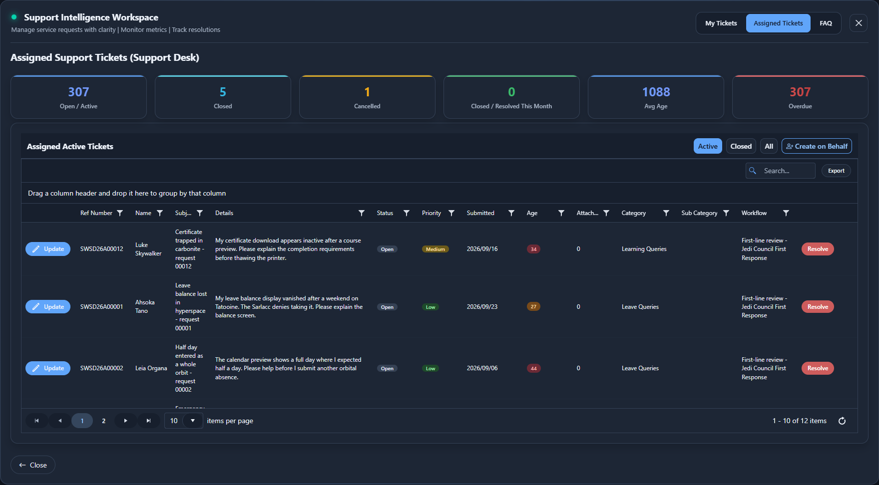
Assigned intake: the support queue presents work for the current support context.
  - Intake and ownership
1. Open Assigned Tickets and select Active. Search for a reference or filter the current category/priority to choose the next item.
2. Open the record and read its description, contact details, documents and activity before taking action. Check the current workflow/assignment context.
3. Confirm the classification and operational priority using the available support fields. Do not rely on the personal form's default priority as a triage decision.
4. Write the response for the requester in the public feedback field. Put support-only working notes in Internal Comments.
5. Save the update and check the result. A request routed to a shared group remains governed by the configured workflow; opening it alone does not claim exclusive ownership.
  - Internal and public feedback
Internal Comments are labelled "support only"; the activity view hides internal comments from the ticket owner. Public response/feedback is intended for the person who logged or receives the request. Check the field label before saving. Explain the outcome in plain language and include the next useful step; avoid exposing internal investigation details in the public field.
  - Reassign to the right support line
1. Choose Reassign when the request belongs with another configured support group.
2. Select the destination group and the required classification. Add Internal Comments explaining the handoff and what has already been checked.
3. Submit and wait for confirmation. Refresh the assigned list because the work may move out of your scope.
4. If no destination is available or the group lookup reports a problem, ask the administrator to check SecondLineSupport and membership. Do not select an unrelated group just to complete the form.
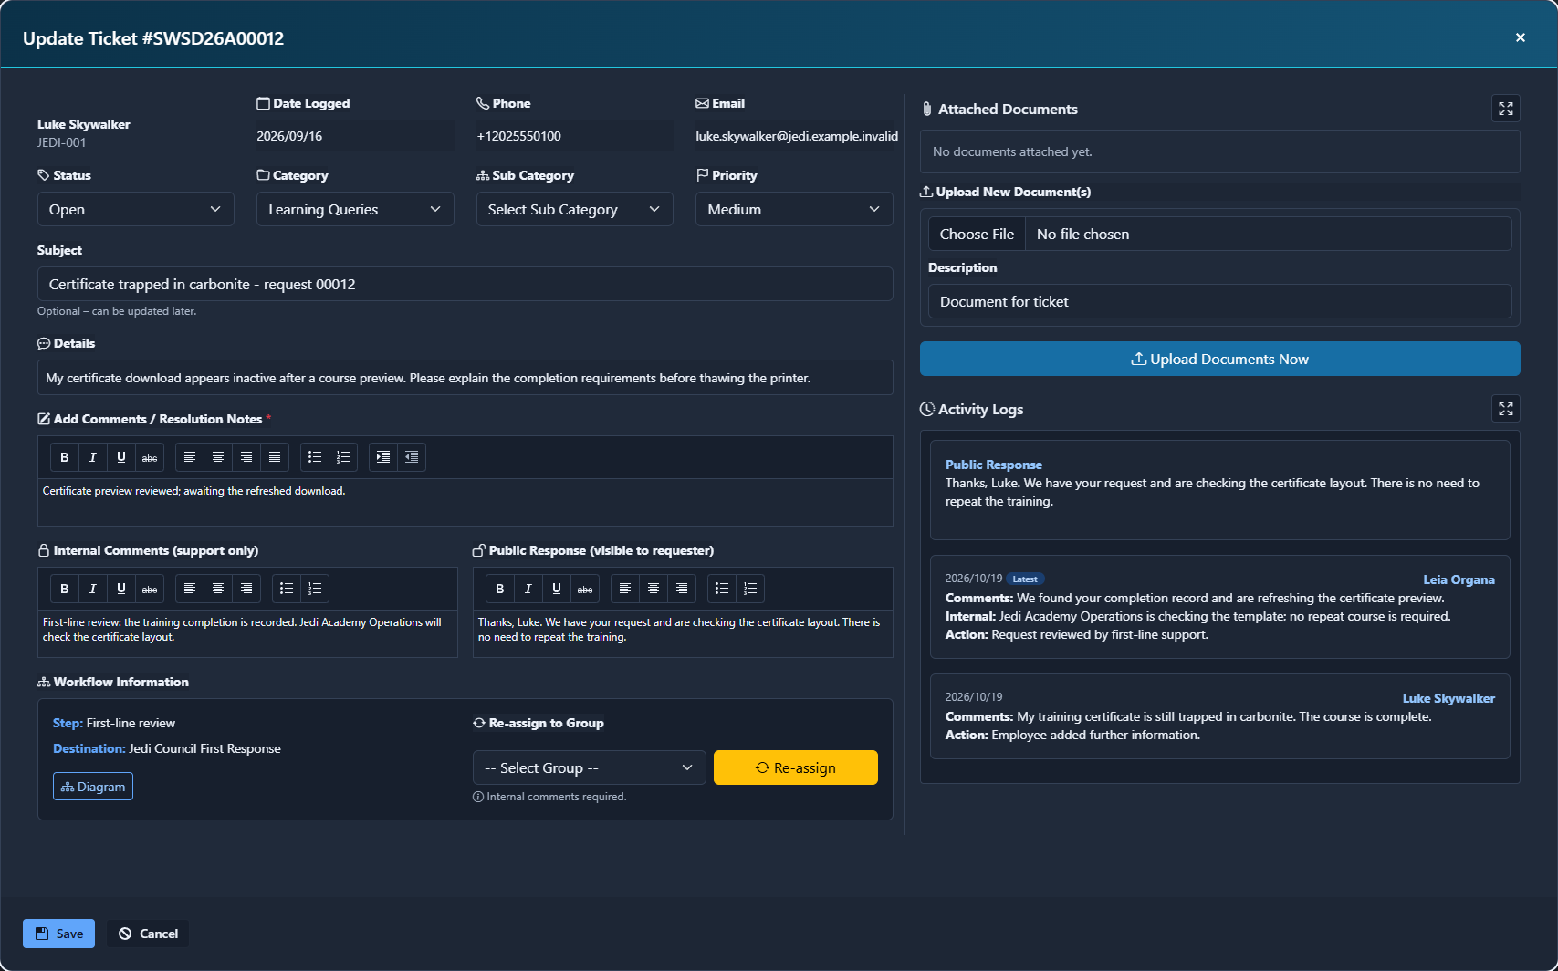
Support update fields separate resolution notes, internal comments, public response and workflow information.
First-line intake, second-line specialists and super users can have different access paths. The selected workflow destination, user/group membership and administrator configuration determine the real outcome. A shared queue is not an automatic "claim ticket" system.
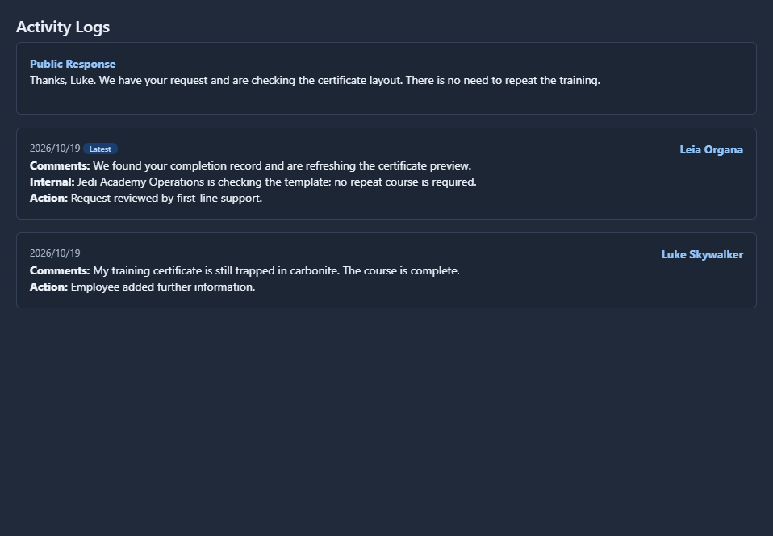
Activity history presents feedback, comments and the recorded action in chronological context.
- Create a request on behalf of an employee
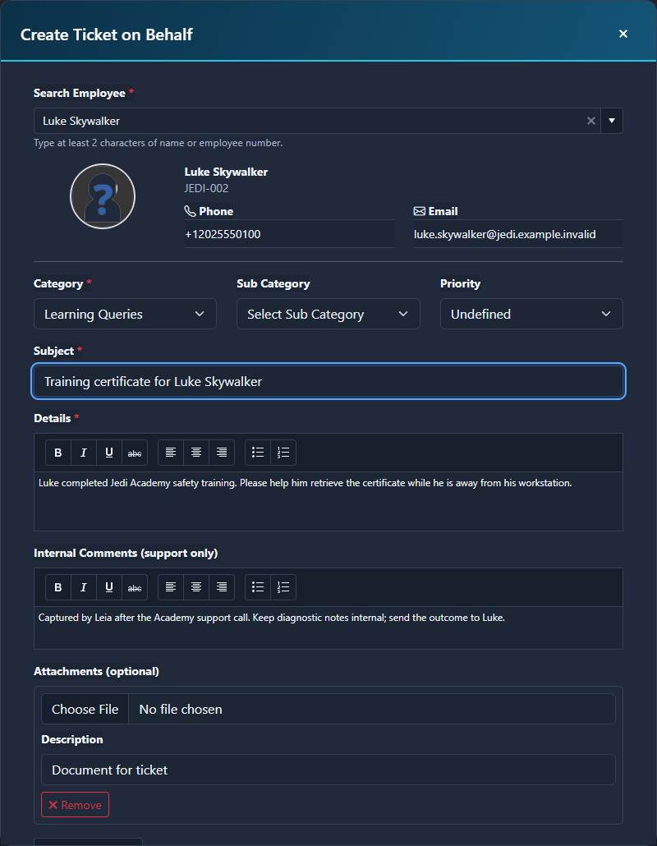
Upper form: select the employee, review their contact preview and complete classification and request details.
  - Confirm the person before submitting
1. In Assigned Tickets, choose Create on Behalf.
2. Type at least two characters of the employee's name or number. Select a returned person rather than leaving only typed text in the search box.
3. Read the preview carefully, including company/employee identity and available phone/email. Stop if it is the wrong person.
4. Select Category and, where available, Sub Category. Complete Subject and Details. Use the support priority field if your process requires it.
5. Add appropriate Internal Comments and attachments with descriptions. Submit once and retain the generated reference.
6. Check the saved request and the attachment result. Explain the reference and expected next step to the employee through your normal authorised support channel.
The on-behalf form requires a selected employee, category, subject and details. Contact values are taken from the selected employee's source details. The system retains the person the request is about and the capturing user, so these are not interchangeable roles. Verify the preview before submitting; an incorrectly selected employee can lead to the wrong ownership and notifications.
  - Keep the communication useful
Capture the employee's actual problem and what they have already tried. A good example is "The holoprojector camera shows blue static during meetings", followed by the browser, device and exact symptoms. Distinguish the employee's words from the agent's internal troubleshooting notes. Do not make the employee repeat a request just because an agent recorded it for them.
Some older menu entries still open an employee selector or the legacy capture screen. Your organisation may route those entries to the modern workspace through its Service Desk version configuration. Use the approved entry point and contact the administrator if the experience differs.
- Resolve, close or cancel with a clear outcome
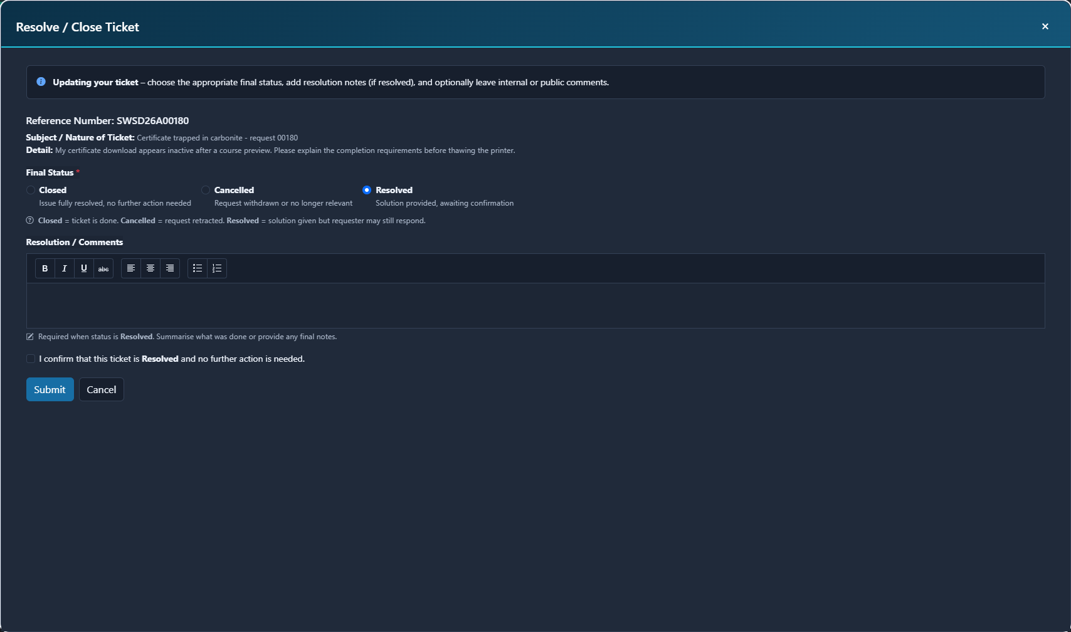
The final-status window distinguishes Resolved, Closed and Cancelled and requires confirmation.
Action | Use it when | What to record
Resolved | The support issue has a known outcome or solution. | Record the resolution and the public next step. For assigned tickets the Resolved action requires resolution notes.
Closed | The request is complete under the organisation's closure process. | Confirm the final outcome and why no further action is needed.
Cancelled | The request is withdrawn, duplicated or no longer needed. | Explain why it is being stopped and quote a replacement reference if appropriate.
1. Open the final-status action for the intended ticket. Recheck the reference and subject.
2. Choose the appropriate final status. Do not use Cancelled merely to hide difficult work.
3. For an assigned resolution, complete Resolution Notes. Add Internal Comments or Public Response where appropriate and available.
4. Read the confirmation statement and tick the confirmation checkbox. Submit once and wait for the result.
5. Refresh the Closed or All view and check the resulting status and dates.
  - Reusable common solutions
When enabled, an assigned support user can mark a Resolved outcome as a common solution. Review and generalise the text first: remove employee-specific facts and retain the steps another person can safely reuse. The server permits publication only by the user recorded as the resolver of that resolved ticket. A title and reusable solution are required.
Common-solution saving happens after the ticket action. If the common-solution save fails, the ticket can still be resolved; read the notification before repeating the action. A common solution is a reusable support entry, not an automatically published FAQ or a guarantee that the same answer fits every future request.
- Use FAQ and improve Knowledge deliberately
  - Get an existing answer first
Use FAQ or Open FAQ from the request form. The standard host opens its shared FAQ modal. Read the full answer and check that it applies to your policy, category and situation. Possible common solutions may also appear as the subject/category is entered when that service is enabled. Selecting one can copy useful text; adjust it before submitting or resolving the ticket.
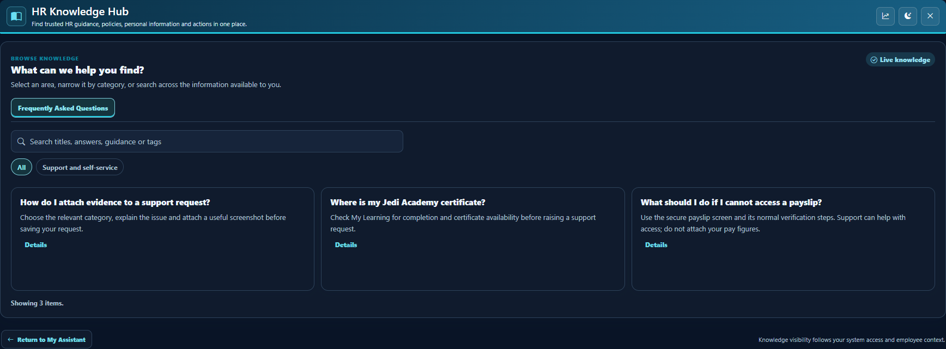
FAQ in Knowledge Hub provides searchable guidance before another request is submitted.
  - From repeated questions to a reviewed answer
1. An authorised editor opens Chatbot Analytics and selects the relevant time range and filters.
2. Review Top Questions, Knowledge Gaps and feedback. Open a question group to read its detail and existing Knowledge action. Popularity and a low rating identify review work; they do not prove an answer is correct or incorrect.
3. If authoring is enabled, choose the available Knowledge action and select FAQ or Knowledge Article, area and category. Write the title, question and short answer, with full content and tags where useful.
4. If an AI draft option is enabled, treat its text as a starting point. Verify every policy, process, date and employee-facing instruction against the organisation's authoritative source.
5. Save a draft for review or explicitly publish when approved under the organisation's editorial process. Reopen Knowledge Hub to confirm the intended item appears.
Only authorised editors can author or publish Knowledge. Review AI drafts and common solutions against authoritative guidance; resolving a ticket does not automatically publish an FAQ.
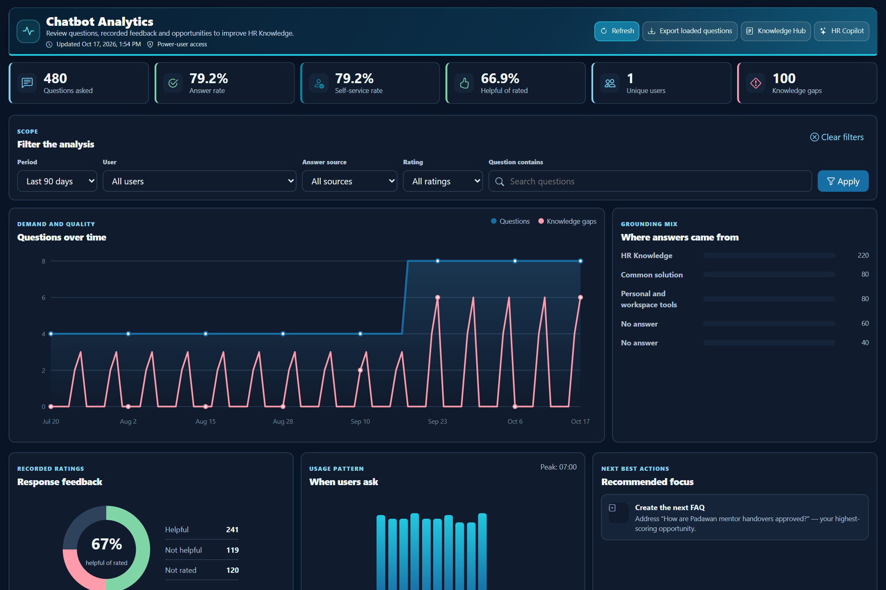
Chatbot Analytics helps authorised editors review repeated questions, feedback and Knowledge gaps.
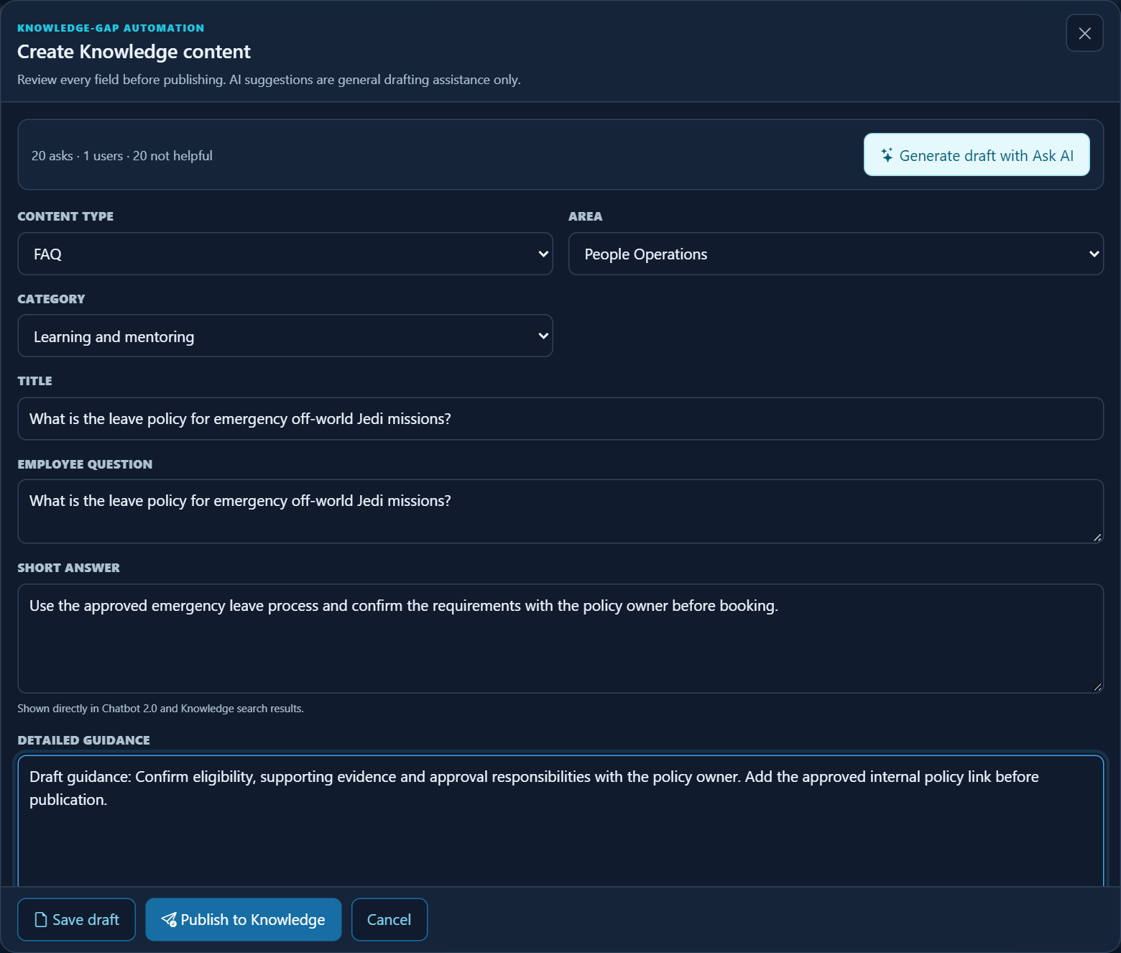
The Knowledge editor separates content review from the explicit Save draft or Publish choice.
- Export a branded Excel workbook and troubleshoot
  - Choose the layout for the download
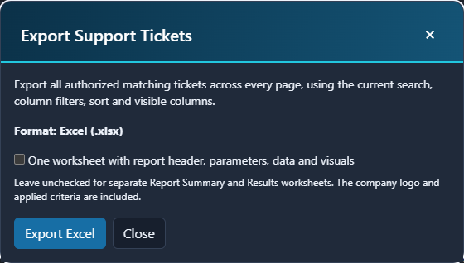
Export Support Tickets fixes the format to Excel and lets the user choose the worksheet layout.
Choose Export on the relevant ticket grid to open Export Support Tickets. Format is fixed to Excel (.xlsx). Check "One worksheet with report header, parameters, data and visuals" for a single Results worksheet; leave it unchecked for Report Summary and Results worksheets. Choose Export Excel, wait for the preparing/download status and inspect the downloaded workbook before sharing.
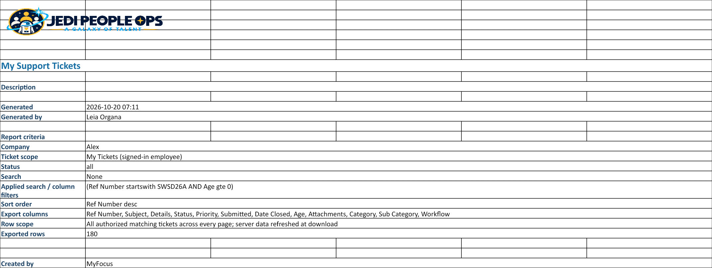
Report Summary records the report identity, selection criteria, preparation details and result count.
Export rechecks the original authorised ticket scope on the server and applies the current status, search and column filters, sorting and permitted visible columns across all matching pages. The result is not limited to the current page. The workbook includes report/company branding, generated details, criteria and row count with typed table values. A correct empty assigned scope stays empty. Check the criteria and rows before sharing support information with the intended recipients.
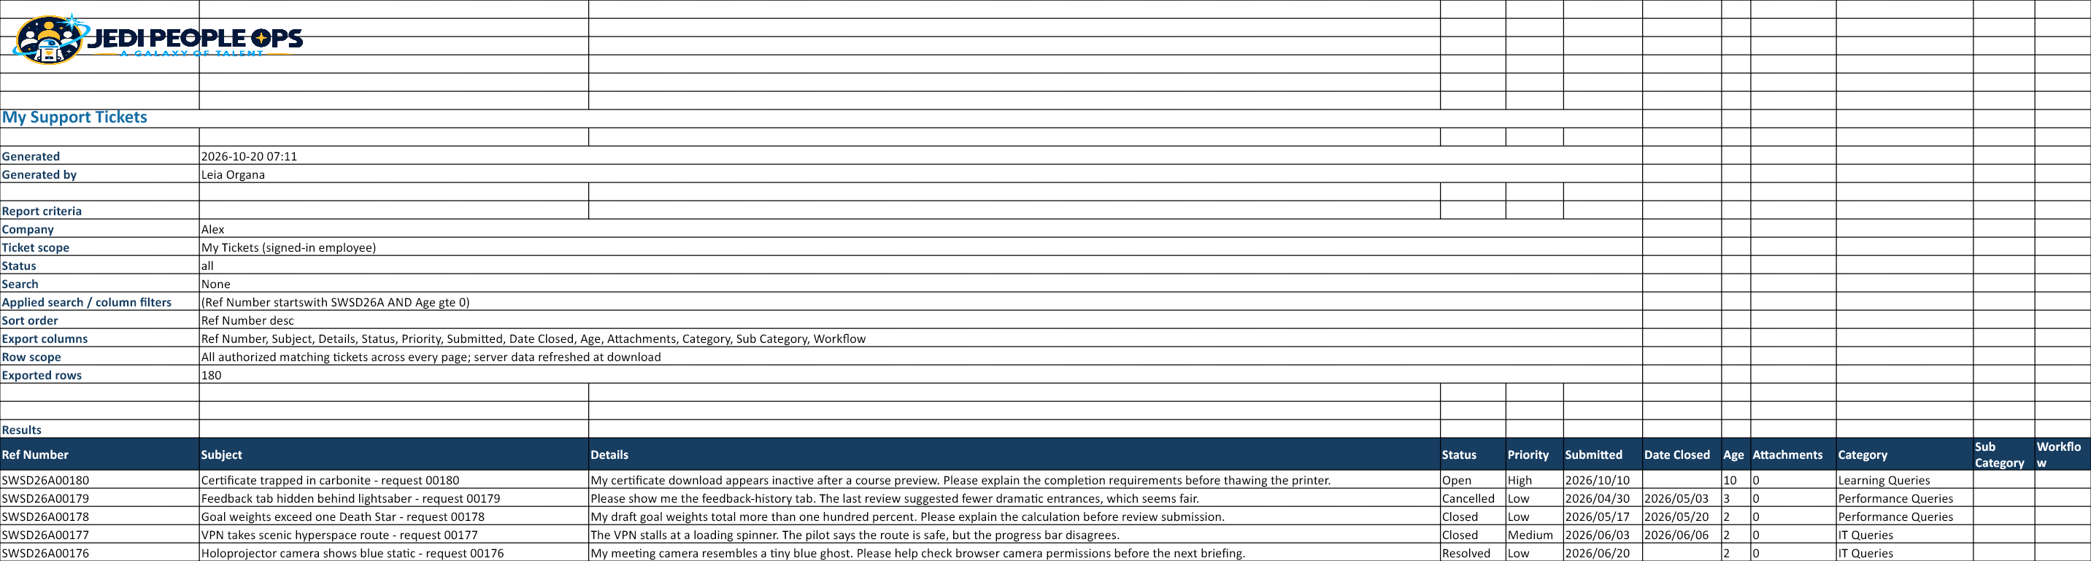
The combined layout keeps the report header, criteria and typed results together on one Results worksheet.
  - Quick troubleshooting
What you see | What to do
No rows | Check My/Assigned, Active/Closed/All and column/search filters; refresh. Ask the administrator to check effective workflow access if needed.
Required field message | Complete the named field. Confirm that an employee was selected in on-behalf mode.
Saved ticket but missing file | Keep the reference, reopen documents and report the upload message. Avoid duplicate tickets.
FAQ does not open | Use the standard My Focus host or ask the administrator to check the parent FAQ host integration.
Common solution unavailable | It may be disabled, have no matching result, or require the actual resolver and Resolved status.
Knowledge authoring/AI unavailable | Ask the editor/administrator about the separate analytics, authoring and AI gates.
Session expired | Sign in again, then search for the reference before resubmitting.

